**PROGRAM ARTICULATION DEGREE PLAN I I I**

I

***Rend Lake Collea• 2019-2020* Southern *11/inlos Universltv Carbondale* I I**

-

**HI$ HI$**

**UNIV101 Saluki Success**

**COMM1101 Prin of Effective Soeaklna 3 CMST101 Intro Oral Conmunication T**

**ENGL1101 Rhetoric & Composition I 3 ENGL101 Enclish Composition I T**

**ENGL1102 Rhetoric & Comoosition II 3 ENGL102 Enclish Comoosition II T**

**MATH1108 Colleae Alaebra 3 MATH108 Cotleae Alaebra T**

**MATH2106 Finite Math 3 MATH139 Finite Mathematics T ECON2101 Princip es of Economics I 3 ECON241 Intro to Macroeconomics T**

**ECON2102 Principles of Economics II 3 ECON240 Intro to Microeconorrics T**

**PSYC2101 Intro to Psychology 3 PSYC102 Intro to Psychology T**

**Fine Arts/Humanities 3 HUMANITIES See *S/UC Transfer Eauivalencv Guide* T**

Humanities **3 HUMANITIES *See S/UC Transfer EQuivalency Guide* T Phvsical Science 3 PHYSICAL SCIENCE See *SIUC Transfer Eauivalencv Guide* T Life Science 4 LIFE SCIENCE See *S/UC Transfer Eauivalency Guide* T**

-

**Fine Arts 3 FINE ARTS *See SIUC Transfer Eauivalencv Guide* T HEA1101 Health Education 2 PH 101** Foundations of Human Health **T**

**MULTICULTURAL**

**42 0**

**An Associate of Arts from a regionally accredited Illinois community college satisfies UCC requirements**

I

**Proaram Reauirements Proaram Reauirements**

**Elective 2 Any courses not articulated will be used to satisfy general elective credit**

**ACCO1101 Prin Financial Accounting 4 ACCT220 Accountina I-Financial T**

**ACCO1102 Prin Managerial Accounting 4 ACCT230 Accounting II-Managerial T BUSI1t01 Intro toBusiness 3 MGMT170 (elective) Intro toBusiness T BUSI2t05 Legal & Social EnvBusiness 3 FIN270 Legal & Social Environment ofBusiness T**

**BUSI2t07 Business Corrmunications 3 ENGL291 lntennediate Technical Writina T CSCI1102 Intro to Cortl)Uters w/Busi Aoo 3 CS200B -or- lSAT229(elective) ColT\r'\I•ter Conceots -or- CornoutinoBusi Admin T**

**22**

**MATH140 Short Course in calculus 4**

**BUS101 O pen forBusiness 2**

**BUS202 Business Career Transitions 2**

**FIN330 Intro to Finance 3**

**MGMT208 Business Data Anatysis** 3

**MGMT304 Intro to Management 3**

**MGMT318 Product�rations Mgmt 3**

**MGMT 345 Con1)uter lnfomlotion Systorre 3**

**MGMT481 Administrative Policy 3**

**MKTG304 Mar1<eting Managemen1 3**

**COB Elective300/400 level ACCT, FIN, MGMT, MKTG 3**

**ACCT321 Intermediate Accounting I 3**

**ACCT322 lnt0fTl10diate Accounting II 3**

**ACCT331 Cost Accounting 3**

**ACCT 341 Intro to Taxation 3**

**ACCT 360 Accounting Systems Operation• 3**

**ACCT421 Advanced Accounting 3**

**ACCT431 Advanced Cost Accounting 3**

**ACCT441 Advanced Tax 3**

**ACCT480 Aud�ing 3**

I

**ACCT Elective**

**ACCT411,485,488,471 -or-495 3**

**62**

**Total semester hrs comoleted with AA dearee: 64 Total semester hrs comcletedwith BS dearee:62**

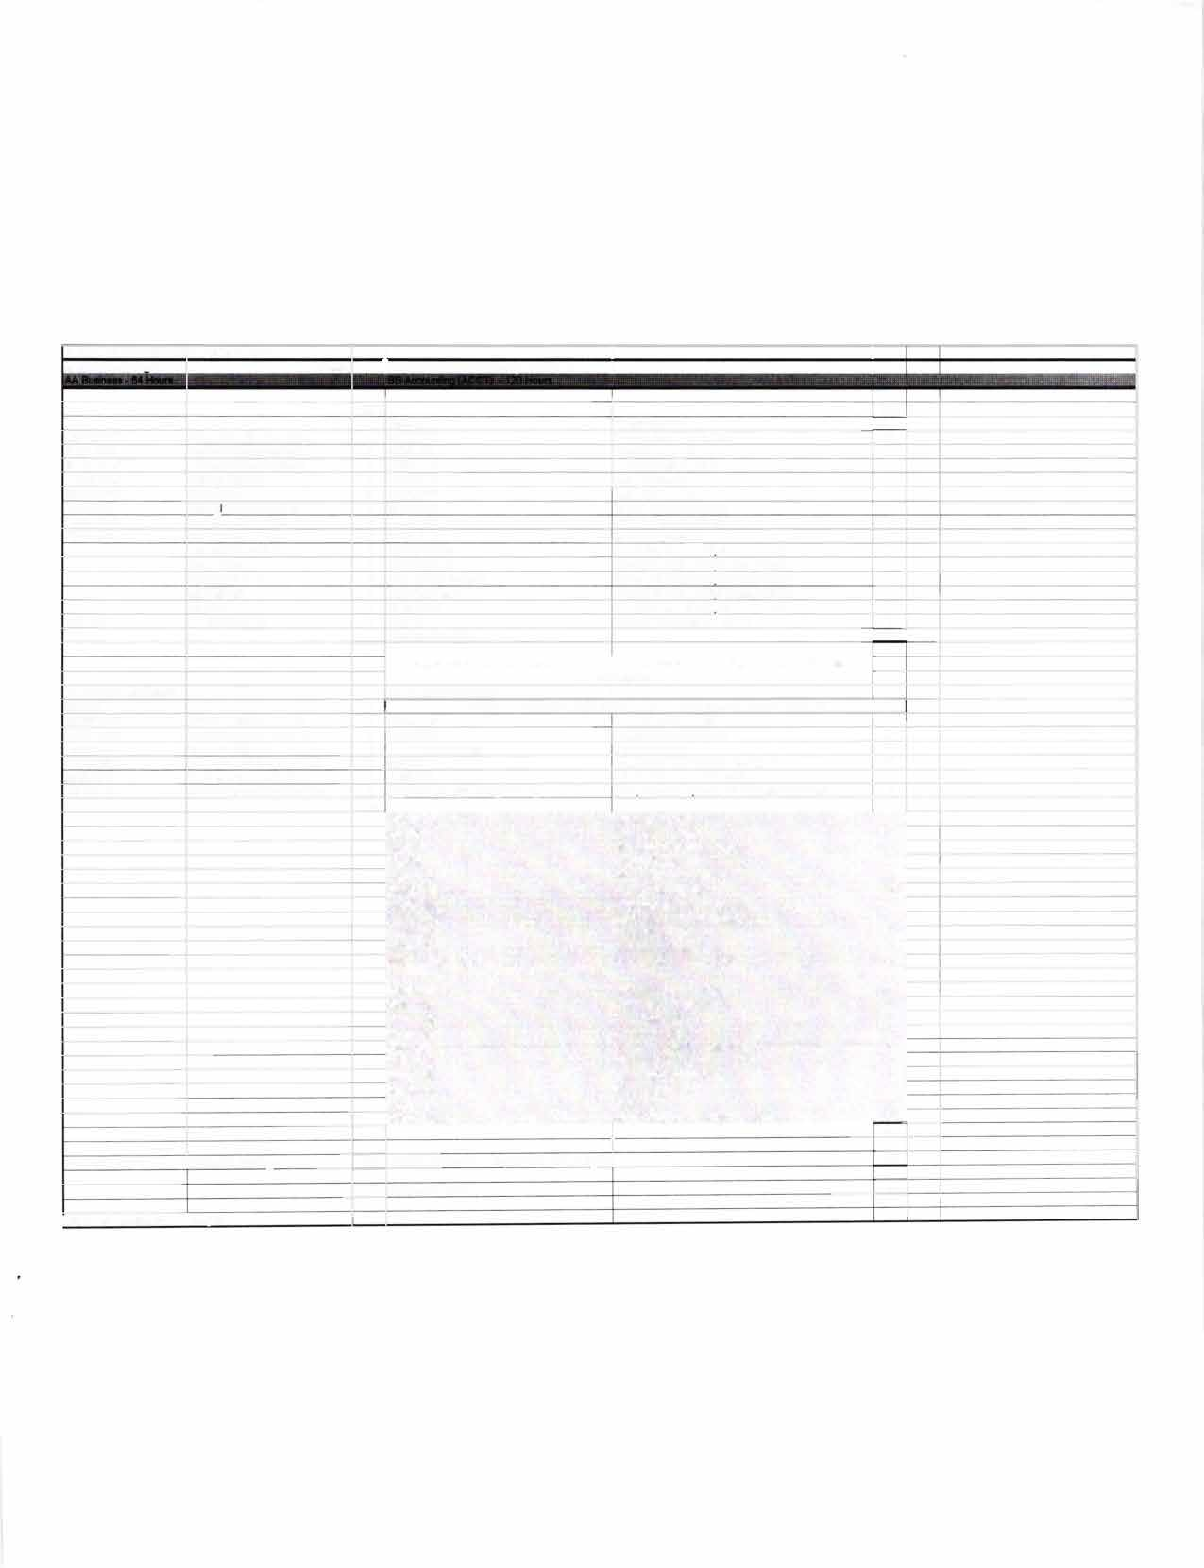

**Total h" to BS decree: 126**

*1rwiree Pfan updat.ed on 21612020 bv SG*

'·,. ·-.

"fJ

��

RE-- ND LAKE

# CARBONDALE

SIU

C, c.·_). I.. l_, E:.: c·.J.-� E::

**TRANSFER GUIDE**

**AA Business transferring into BS Accounting**

**Rend Lake College Courses AA Business - 64 hours**

|  |  |  |  |
| --- | --- | --- | --- |
| ENGL 1101-3 | Rhetoric & Composition I | ECON 2101-3 | Principles of Economics I |
| ENGL 1102-3 | Rhetoric & Composition II | ECON 2102-3 | Principles of Economics II |
| COMM 1101-3 | Principles of Effective Speaking | MATH 2106-3 | Finite Math |
| MATH 1108-3 | College Algebra | ACCO 1101-4 | Principles of Financial Accounting |
| PSYC 2101-3 | Intro to Psychology | ACCO 1102-4 | Principles of Managerial Accounting |
| HEA 1101-2 | Health Education | BUSI 1101-3 | Intro to Business |
| Humanities-3 | | BUSI 2105-3 | Legal/Social Environment of Business |
| Humanities/Fine Arts-3 | | BUSI 2107-3 | Business Communications |
| Physical Science-3 | | CSCI 1102-3 | Intro to Comp w/ Business Application |
| Life Science-4 | | Elective-2 | |
| Fine Arts-3 | |  | |

**Southern Illinois University Carbondale Courses BS Accounting (ACCT) - 62 hours**

|  |  |  |  |
| --- | --- | --- | --- |
| MATH 140-4 | Short Course in Calculus | ACCT 321-3 | Intermediate Accounting I |
| BUS 101-2 | Open for Business | ACCT 322-3 | Intermediate Accounting II |
| BUS 202-2 | Business Career Transitions | ACCT 331-3 | Cost Accounting |
| FIN 330-3 | Intro to Finance | ACCT 341-3 | Intro to Taxation |
| MGMT 208-3 | Business Data Analysis | ACCT 360-3 | Accounting Systems Operations |
| MGMT 304-3 | Intro to Management | ACCT 421-3 | Advanced Accounting |
| MGMT 318-3 | Production-Operations Mgmt | ACCT 431-3 | Advanced Cost Accounting |
| MGMT 345-3 | Computer Information Systems | ACCT 441-3 | Advanced Tax |
| MGMT 481-3 | Administrative Policy | ACCT 460-3 | Auditing |
| MKTG 304-3 Marketing Management  COB Elective-3 300/400-level | | ACCT Elective-3 | ACCT 411, 465, 468, 471-or- 495 |

**Total Hours to Bachelor Degree: 126 Hours**

**Questions? Contact Us!**

**Rend Lake College**

Jena Jensik

Director of Academic Advising

**Salary Range:**

$46,000-$78,000

P: 618-437-5321, ext. 1293

E: [jensikj@rlc.edu](mailto:jensikj@rlc.edu)

**Possible Careers:** Certified Public Accountant

Internal Auditor Budget Analyst Consultant

**Southern Illinois University Carbondale**

Jasmine Winters

Chief Academic Advisor

**P: 618-453-7496**

E: [jwinters@business.siu.edu](mailto:jwinters@business.siu.edu)

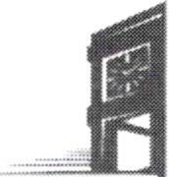

Disclaimer: You are encouraged to use this transfer guide when planning your progress towards degree completion. F�llowing a transfer guide does not guarantee admission into the listed program. Information is attempted to be kept current; howeve�, any c�mculum c�ange� ref�ected in the Undergraduate Catalog override the information on this guide. Contact your Academic Advisor for assistance in interpreting this guide.



# CARBONDALE

**SIU**

**Baccalaureate Degree Requirements**

Each candidate for a bachelor's degree must complete the requirements listed:

***Hour Requirements.*** Each student must complete at least 120 semester hours of credit. Each student must have at least 42 hours in courses that number 300 or above from a four-year institution.

***Residence Requirements.*** Each student must complete the residence requirement by taking the last year, which is defined as 30 uninterrupted semester hours, or a total of 90 semester hours at SIU Carbondale.

***Grade Point Average Requirements.*** Each student must have a *C* average for all work taken at SIU Carbondale. Some academic programs may require a higher graduating major GPA.

**Dual Admission Program**

The Dual Admission Program (DAP) allows baccalaureate-oriented students at eligible community colleges to benefit from pre-advisement for a chosen major at SIU Carbondale. The DAP addresses specific departmental requirements that a student may not automatically fulfill by completing their associate degree at their community college. Students apply to the OAP by completing the Application for Undergraduate Admission and indicating interest in the OAP. Students must have at least two semesters remaining at their community college to participate, must select a participating SIU major, and must attend an eligible community college. Students who apply for the OAP are provided a transfer plan that will guide them to the most direct route to their bachelor's degree, along with personalized contact with an SIU representative. Dual Admission Program students receive access to enroll in an online Dual Admission Program course, which connects students early to the University, its resources, and other transfer students.

**Compact Agreement**

SIU has recognized the Illinois regionally accredited community college transferable baccalaureate oriented Associate of Arts or Associate of Science degrees under the Compact Agreement since 1970. SIU will continue to recognize the baccalaureate oriented associate degree (A.A. or A.S. degree) under the Illinois Articulation Initiative as satisfying SIU University Core Curriculum (UCC). The Associate of Applied Science (A.A.S.), Associate in Engineering Science (A.E.S.), the Associate in General Studies (A.G.S.), and the Associate in Fine Arts (A.F.A.) are not covered under the Compact Agreement and do not carry the same benefits as the A.A. and A.S. degrees.

**Degree Works**

*Degree Works* is an easy-to-use, comprehensive, online degree audit tool specifically designed for students. The audit reflects program requirements from the Undergraduate Catalog measured against registration and transfer work to guide the degree audit function as it applies to the individual student. Once admitted to SIU Carbondale, you can run a Degree Works degree audit against your academic record by searching "Degree Works" in SalukiNet.