**PROGRAM ARTICULATION DEGREE PLAN**

***Rend Lake College 2019-2020*** *Southern llllnlos University Carbondale*

**H1>**

|  |  |  |  |  |  |
| --- | --- | --- | --- | --- | --- |
|  | | | **UNIV101** | **Saluki Success** |  |
| **COMM1101** | **Pm of Effective Speaking** | **3** | **CMST101** | **Intro Oral Communication** | **T** |
| **ENGL1101** | **Rhetoric & Composition I** | **3** | **ENGL101** | **En lish Comoosition I** | **T** |
| **ENGL1102** | **Rhetoric & Comoosition II** | **3** | **ENGL102** | **Enalish Comoosition II** | **T** |
| **MATH1108** | **Coleoe Aloebra** | **3** | **MATH108** | **CoUeae Aloebra** | **T** |
| **MATH2106** | **Finite Math** | **3** | **MATH139** | **Finite Mathematics** | **T** |
| **ECON2101** | **PITlcioles of Economics I** | **3** | **ECON241** | **Intro to Macroeconomics** | **T** |
| **ECON2102** | **Princioles of Economics II** | **3** | **ECON240** | **Intro to Microeconomics** | **T** |
| **PSYC2101** | **Intro to Psvcholoav** | **3** | **PSYC102** | **Intro to Psvchok>av** | **T** |
|  | **Fine Arts/Humanities** | **3** | **HUMANITIES** | **See *SJUC Transfer Equrvafency Gwde*** | **T** |
|  | **Humanities** | **3** | **HUMANITIES** | **See *SIUC Transfer Equrvalency Gulde*** | **T** |
|  | **Physical Science** | **3** | **PHYSICAL SCIENCE** | **See *SIUC Transfer £quiva/ency Gulde*** | **T** |
|  | **Life Science** | **4** | **LIFE SCIENCE** | ***See SIUC Transf8r Equivalency Gukte*** | **T** |
| **HEA1101** | **Health Education** | **2** | **PH101** | **Foundations of Human Health** | **T** |
|  | **Fine Arts** | **3** | **FINE ARTS** | **See *S/UC Transfer Eouivafencv Gulde*** | **T** |

-**H1>**

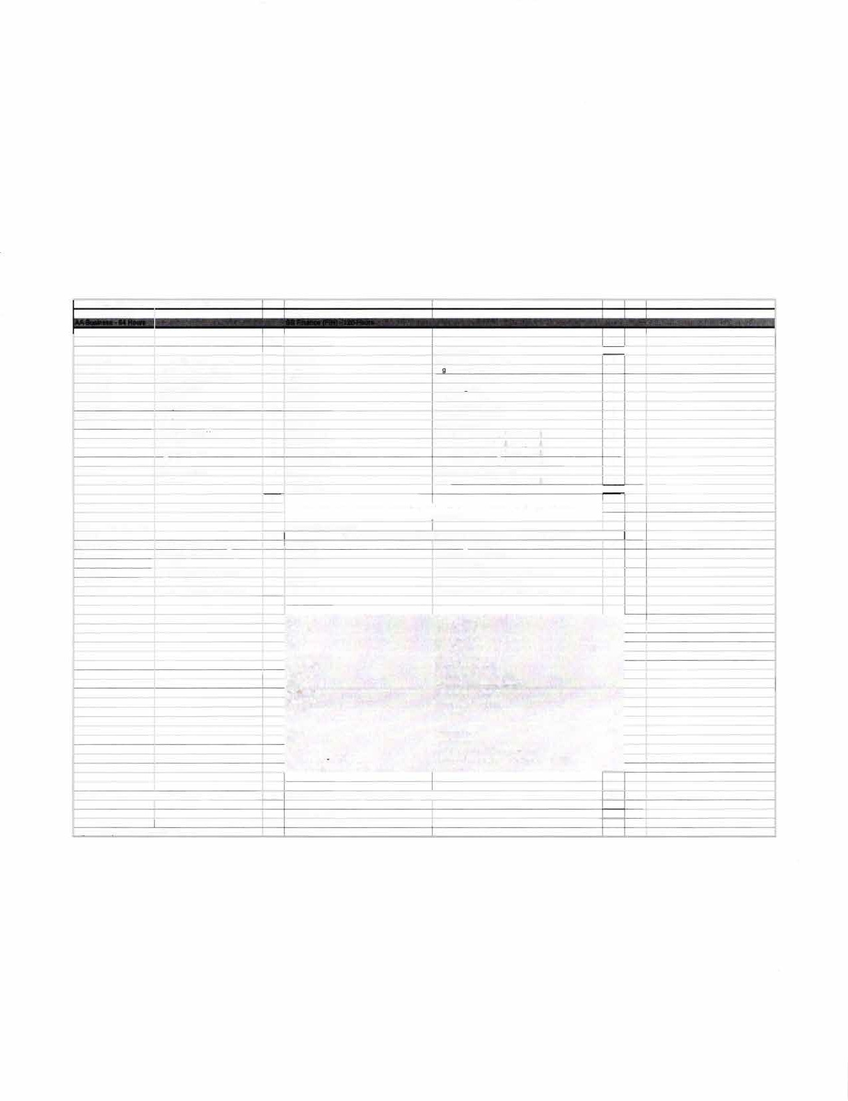

**MULTICULTURAL** -

**42 0**

**An Associate of Arts from a regionalty accredited Illinois corrmunity college satisfies UCC requirements**

**Proaram Reauirements Proaram Reauirements**

**Elective 2 Any courses not articulated will be used to satisfy general elective credit**

|  |  |  |  |  |  |  |
| --- | --- | --- | --- | --- | --- | --- |
| **ACCO1101** |  | **Prin Financial Accountino** | **4** | **ACCT220** | **Account.lo I-Financial** | **T** |
| **ACCO1102** |  | **Prin Manaoerial Accountino** | **4** | **ACCT230** | **Account.la II-Manaaerial** | **T** |
| **BUSI1101** |  | **Intro to Business** | **3** | **MGMT170** | **Intro to Business** | **T** |
| **BUSI2105** |  | **Leaal & Social Env Business** | **3** | **FIN270** | **Legal & Social Envi"onment of Business** | **T** |
| **BUSI2107** |  | **Business Communications** | **3** | **ENGL291** | **Intermediate Technical Writing** | **T** |
| **CSCI1102** |  | **Intro to Computers w/Busi Ano** | **3** | **CS200 B-or- lSAT229** | **Computer Concepts -or- Computing Busi Admin** | **T** |
|  |  |  | **22** |  |  |  |
|  |  |  |  |  |  |  |
|  |  |  |  | **MATH140** | **Short Course in Calwlua** | **4** |
|  |  |  |  | **BUS101** | **OpenlorBusii...** | **2** |
|  |  |  |  | **BUS202** | **Bullnest Career Trandk>ns** | **2** |
|  |  |  |  | **FIN330** | **lntroto FW!ance** | **3** |
|  |  |  |  | **MGMT208** | **eu.1r1- Data Anolysll** | **3** |
|  |  |  |  | **MGMT304** | **Intro toManagement** | **3** |
|  |  |  |  | **MGMT318** | **Production-Operations Mgmt** | **3** |
|  |  |  |  | **MGMT:1<45** | **Computer Information Sysloms** | **3** |
|  |  |  |  | **MGMT"81** | **AdmlnillnltlYe Poley** | **3** |
|  |  |  |  | **MKTG304** | **Martceting Ma,agement** | **3** |
|  |  |  |  | **COB Elective** | **30014004evet** | **3** |
|  |  |  |  |  |  |  |
|  |  |  |  | **FIN331** | **Investments** | **3** |
|  |  |  |  | **FIN:1<41** | **Financial Marll:etl** | **3** |
|  |  |  |  | **FIN361** | **Management of BuslneM Finance** | **3** |
|  |  |  |  | **ACCT321 -orACCT331** | **lntermecbteAccounting I-or- CostAccounting** | **3** |
|  |  |  |  | **Spedoiza1ion** |  | **15** |
|  |  |  |  |  |  | **59** |

**Total semester h rs completed with AA dearee: u Total semester hrs completed with BS deal"H:** **59**

**Total hrs to BS degree: 123**

*,._,_. Plan uodated on 2/&2020 bv SG*

! � SIU

►-,

=-

# REND LA.KE

C) LECiE

**TRANSFER GUIDE**

**AA Business transferring into BS Finance**

**CARBONDALE**

**Rend Lake College Courses AA Business - 64 hours**

|  |  |  |  |
| --- | --- | --- | --- |
| ENGL 1101-3 | Rhetoric & Composition I | ECON 2101-3 | Principles of Economics I |
| ENGL 1102-3 | Rhetoric & Composition II | ECON 2102-3 | Principles of Economics II |
| COMM 1101-3 | Principles of Effective Speaking | MATH 2106-3 | Finite Math |
| MATH 1108-3 | College Algebra | ACCO 1101-4 | Principles of Financial Accounting |
| PSYC 2101-3 | Intro to Psychology | ACCO 1102-4 | Principles of Managerial Accounting |
| HEA 1101-2 | Health Education | BUSI 1101-3 | Intro to Business |
| Humanities-3 | | BUSI 2105-3 | legal/Social Environment of Business |
| Humanities/Fine Arts-3 | | BUSI 2107-3 | Business Communications |
| Physical Science-3 | | CSCI 1102-3 | Intro to Comp w/ Business Application |
| life Science-4 | | Elective-2 | |
| Fine Arts-3 | |  | |

**Southern Illinois University Carbondale Courses BS Finance (FIN) - 59 hours**

|  |  |  |  |
| --- | --- | --- | --- |
| MATH 140-4 | Short Course in Calculus | MGMT 481-3 | Administrative Policy |
| BUS 101-2 | Open for Business | MKTG 304-3 | Marketing Management |
| BUS 202-2 | Business Career Transitions | COB Elective-3 | 300/400-level |
| FIN 330-3 | Intro to Finance | FIN 331-3 | Investments |
| MGMT 208-3 | Business Data Analysis | FIN 341-3 | Financial Markets |
| MGMT 304-3 | Intro to Management | FIN 361-3 | Management of Business Finance |
| MGMT 318-3 | Production-Operations Mgmt | ACCT 321/331-3 | lntermed Acct I/Cost Accounting |
| MGMT 345-3 | Computer Information Systems | Specialization-15 | |

**Total Hours to Bachelor Degree: 123 Hours**

## Questions? Contact Us!

**Salary Range:**

$46,000-$55,000

**Rend lake College**

Jena Jensik

Director of Academic Advising

**Possible Careers:** Financial Planner

Investor Relations Associate Financial Analyst

Budget Analyst Credit Analyst

P:618-437-5321,ext. 1293

E: [jensikj@rlc.edu](mailto:jensikj@rlc.edu)

**Southern Illinois University Carbondale**

Jasmine Winters

Chief Academic Advisor P: 618-453-7496

E: [jwinters@business.siu.edu](mailto:jwinters@business.siu.edu)

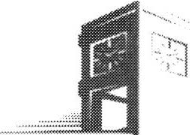

Disclaimer: You are encouraged to use this transfer guide when planning your progress towards degree completion. Following a transfer guide does not guarantee admission into the listed program. Information is attempted to be kept current; however, any curriculum changes reflected in the Undergraduate Catalog override the information on this guide. Contact your Academic Advisor for assistance in interpreting this guide.



## CARBONDALE

SIU

**Baccalaureate Degree Requirements**

Each candidate for a bachelor's degree must complete the requirements listed:

***Hour Requirements.*** Each student must complete at least 120 semester hours of credit. Each student must have at least 42 hours in courses that number 300 or above from a four-year institution.

***Residence Requirements.*** Each student must complete the residence requirement by taking the last year, which is defined as 30 uninterrupted semester hours, or a total of 90 semester hours at SIU Carbondale.

***Grade Point Average Requirements.*** Each student must have a *C* average for all work taken at SIU Carbondale. Some academic programs may require a higher graduating major GPA.

**Dual Admission Program**

The Dual Admission Program (DAP) allows baccalaureate-oriented students at eligible community colleges to benefit from pre-advisement for a chosen major at SIU Carbondale. The DAP addresses specific departmental requirements that a student may not automatically fulfill by completing their associate degree at their community college. Students apply to the DAP by completing the Application for Undergraduate Admission and indicating interest in the DAP. Students must have at least two semesters remaining at their community college to participate, must select a participating SIU major, and must attend an eligible community college. Students who apply for the DAP are provided a transfer plan that will guide them to the most direct route to their bachelor's degree, along with personalized contact with an SIU representative. Dual Admission Program students receive access to enroll in an online Dual Admission Program course, which connects students early to the University, its resources, and other transfer students.

**Compact Agreement**

SIU has recognized the Illinois regionally accredited community college transferable baccalaureate oriented Associate of Arts or Associate of Science degrees under the Compact Agreement since 1970. SIU will continue to recognize the baccalaureate oriented associate degree (A.A. or A.S. degree) under the Illinois Articulation Initiative as satisfying SIU University Core Curriculum (UCC). The Associate of Applied Science (A.A.S.), Associate in Engineering Science (A.E.S.), the Associate in General Studies (A.G.S.), and the Associate in Fine Arts (A.F.A.) are not covered under the Compact Agreement and do not carry the same benefits as the A.A. and A.S. degrees.

**Degree Works**

*Degree Works* is an easy-to-use, comprehensive, online degree audit tool specifically designed for students. The audit reflects program requirements from the Undergraduate Catalog measured against registration and transfer work to guide the degree audit function as it applies to the individual student. Once admitted to SIU Carbondale, you can run a Degree Works degree audit against your academic record by searching "Degree Works" in SalukiNet.