**PROGRAM ARTICULATION DEGREE PLAN**

***Rend lake College 20111-2020 Southern lllfnio• University Carbondale***

-

**Hrs Hrs**

**UNIV101 Saluki Success**

**COMM1101 Prin of Effective Soeaking 3 CMST101 Intro Oral Communication T**

**ENGL1101 Rhetoric & Composition I 3 ENGL101 Enalish Comoosition I T**

**ENGL1102 Rhetoric & Comoosition II 3 ENGL102 Enalish Comooaition II T**

**MATH1108 Colleoe Alaebra 3 MATH108 Colleae Aloebra T**

**MATH2106 Finite Math 3 MATH139 Finite Mathematics T**

**ECON2101 Princiixes of Economics I 3 ECON2•1 Intro to Macroeconomics T**

**ECON2102 Princioles of Economics II 3 ECON2•0 Intro to Microeconomics T**

**PSYC2101 Intro to Psychology 3 PSYC102 Intro to Psychology T**

**Fine Arts/Humanities 3 HUMAN1TIES See *SJUC Transfer Ec,urvalency Guide* T**

**Humanities 3 HUMANITIES *See SJUC Transfer Ec,utvalency Guide* T**

•

**Physical Science 3**

**Life Science**

**PHYSICAL SC1ENCE See SIUC *Transfer Eaurva/encv Guide* T**

**LIFE SCIENCE See *S/UC Transfsr Eautvafencv Guide* T**

-

**HEA1101 Health Education 2 PH101 Foundations of Human Health T Fine Arts 3 FINE ARTS See *SIUC* Transfer *Eautvalencv Guide* T**

**MULTICULTURAL**

**•2 0**

**An Associate of Arts from a regionally accredited Illinois community coUege satisfies UCC requirements**

**Proaram Reauirements Proaram Reauiren.nts**

**Elective 2**•

|  |  |  |  |  |  |
| --- | --- | --- | --- | --- | --- |
|  | | | | | **T** |
| **ACCO1102 Prin Manaaerial Accountina ACCT230 Accountina 11-Manaaerial** | | | | | **T** |
| **BUSI1101** | **Intro to Business** | **3** | **MGMT170** | **Intro to Business** | **T** |
| **BUSI2105** | **Leaal & Social Env Business** | **3** | **FIN270** | **Legal & Social Environment of Business** | **T** |
| **BUSI2107** | **Business Communications** | **3** | **ENGL291** | **Intermediate Technical Writing** | **T** |
| **CSCI1102** | **Intro to Computers wfBusi App** | **3** | **CS2008 -or- lSAT229** | **Computer Concepts *-or-* ComputingBusi Admin** | **T** |
| **22**  **MATH1•0** | | | | **Short *Cou!M* In C.iallus** | • |
| **BUS101** | | | | **Openfo<Busln...** | **2** |
| **BUS202** | | | | **ButneN C.reer Traneidont** | **2** |
| **FIN330** | | | | **Intro to Fnance** | **3** |
| **MGMT208** | | | | **Businea D1tl Analyl,ie** | **3** |
| **MGMTJa.** | | | | **Intro to Management** | **3** |
| **MGMT318** | | | | **Produdion-OpOfltionl Mgm1** | **3** |
| **MGMT�5** | | | | **Computer lnfofmatlon System,** | **3** |
| **MGMH81** | | | | **Adminlltradv1 Poley** | **3** |
| **MKTGJa.** | | | | **Marketing Management** | **3** |
| **COB Elective** | | | | **300/400-level** | **3** |

**Any courses not articulated will be used to satisfygeneral ektctive credit**

**ACCO1101 Prin Financial Accountina**

* **ACCT220 Accountina 1-Financiat**

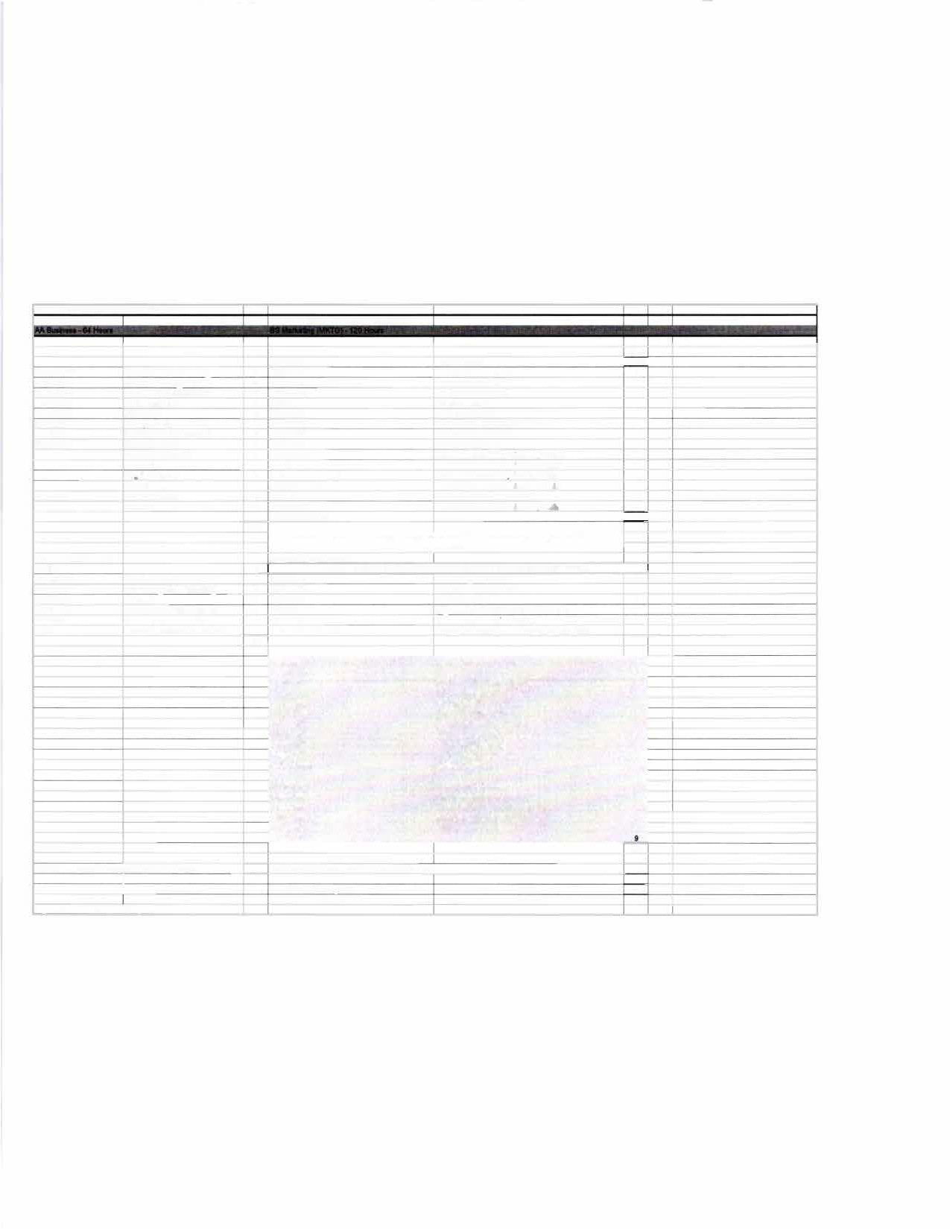

**MKTG305 Contumer Behavior 3**

**MKTG329 M00teling Channell 3**

**MKTG 383 Strategic Promotion Management 3**

**MKTG3110 Marketing Retearch and Anafyail 3**

**MKTG•U Matkeling S1rltegy 3**

**MKTGElectivn**

**56**

**Total sermsterhrs eomoleted with AA dearee:** H **Total semester hrs completed with BS degree: 56**

I

I **Total hrs to BS dearee: *120***

***n,,.,.,,,,.,,, Ptan updatedon 2/6'2020 by SG***

►,-**-=t**,**.**

F

SIU

# t END LAKE

C)L.L.ECiE

**TRANSFER GUIDE**

**AA Business transferring into BS Marketing**

## CARBONDALE

**Rend Lake College Courses AA Business - 64 hours**

|  |  |  |  |
| --- | --- | --- | --- |
| ENGL 1101-3 | Rhetoric & Composition I | ECON 2101-3 | Principles of Economics I |
| ENGL 1102-3 | Rhetoric & Composition II | ECON 2102-3 | Principles of Economics II |
| COMM 1101-3 | Principles of Effective Speaking | MATH 2106-3 | Finite Math |
| MATH 1108-3 | College Algebra | ACCO 1101-4 | Principles of Financial Accounting |
| PSYC 2101-3 | Intro to Psychology | ACCO 1102-4 | Principles of Managerial Accounting |
| HEA 1101-2 | Health Education | BUSI 1101-3 | Intro to Business |
|  | Humanities-3 | BUSI 2105-3 | Legal/Social Environment of Business |
|  | Humanities/Fine Arts-3 | BUSI 2107-3 | Business Communications |
|  | Physical Science-3 | CSCI 1102-3 | Intro to Comp w/ Business Application |
|  | Life Science-4 Fine Arts-3 | Elective-2 |  |

**Southern Illinois University Carbondale Courses BS Marketing (MKTG) - 56 hours**

|  |  |  |  |
| --- | --- | --- | --- |
| MATH 140-4 | Short Course in Calculus | MKTG 304-3 | Marketing Management |
| BUS 101-2 | Open for Business | COB Elective-3 | 300/400-level |
| BUS 202-2 | Business Career Transitions | MKTG 305-3 | Consumer Behavior |
| FIN 330-3 | Intro to Finance | MKTG 329-3 | Marketing Channels |
| MGMT 208-3 | Business Data Analysis | MKTG 363-3 | Strategic Promotion Management |
| MGMT 304-3 | Intro to Management | MKTG 390-3 | Marketing Research & Analysis |
| MGMT 318-3 | Production-Operations Mgmt | MKTG 493-3 | Marketing Strategy |
| MGMT 345-3 | Computer Information Systems | MKTG Elec-9 | |
| MGMT 481-3 | Administrative Policy |  | |

**Total Hours to Bachelor Degree: 120 Hours**

## Questions? Contact Us!

**Rend Lake College**

Jena Jensik

Director of Academic Advising

**Salary Range:**

$41,000-$51,000

P: 618-437-5321, ext. 1293

E: [jensikj@rlc.edu](mailto:jensikj@rlc.edu)

**Possible Careers:** Marketing Account Executive

Marketing Analyst Marketing Assistant Business Dev Representative

Marketing Sales Representative

**Southern Illinois University Carbondale**

Jasmine Winters

Chief Academic Advisor P: 618-453-7496

E: [jwinters@business.siu.edu](mailto:jwinters@business.siu.edu)

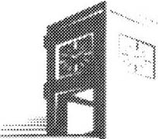

Disclaimer: You are encouraged to use this transfer guide when planning your progress towards degree completion. Following a transfer guide does not guarantee admission into the listed program. Information is attempted to be kept current; however, any curriculum changes reflected in the Undergraduate Catalog override the information on this guide. Contact your Academic Advisor for assistance in interpreting this guide.



## CARBONDALE

**SIU**

**Baccalaureate Degree Requirements**

Each candidate for a bachelor's degree must complete the requirements listed:

***Hour Requirements.*** Each student must complete at least 120 semester hours of credit. Each student must have at least 42 hours in courses that number 300 or above from a four-year institution.

***Residence Requirements.*** Each student must complete the residence requirement by taking the last year, which is defined as 30 uninterrupted semester hours, or a total of 90 semester hours at SIU Carbondale.

***Grade Point Average Requirements.*** Each student must have a C average for all work taken at SIU Carbondale. Some academic programs may require a higher graduating major GPA.

**Dual Admission Program**

The Dual Admission Program (DAP) allows baccalaureate-oriented students at eligible community colleges to benefit from pre-advisement for a chosen major at SIU Carbondale. The DAP addresses specific departmental requirements that a student may not automatically fulfill by completing their associate degree at their community college. Students apply to the OAP by completing the Application for Undergraduate Admission and indicating interest in the DAP. Students must have at least two semesters remaining at their community college to participate, must select a participating SIU major, and must attend an eligible community college. Students who apply for the DAP are provided a transfer plan that will guide them to the most direct route to their bachelor's degree, along with personalized contact with an SIU representative. Dual Admission Program students receive access to enroll in an online Dual Admission Program course, which connects students early to the University, its resources, and other transfer students.

**Compact Agreement**

SIU has recognized the Illinois regionally accredited community college transferable baccalaureate oriented Associate of Arts or Associate of Science degrees under the Compact Agreement since 1970. SIU will continue to recognize the baccalaureate oriented associate degree (A.A. or A.S. degree) under the Illinois Articulation Initiative as satisfying SIU University Core Curriculum (UCC). The Associate of Applied Science (A.A.S.), Associate in Engineering Science (A.E.S.), the Associate in General Studies (A.G.S.), and the Associate in Fine Arts (A.F.A.) are not covered under the Compact Agreement and do not carry the same benefits as the A.A. and A.S. degrees.

**Degree Works**

*Degree Works* is an easy-to-use, comprehensive, online degree audit tool specifically designed for students. The audit reflects program requirements from the Undergraduate Catalog measured against registration and transfer work to guide the degree audit function as it applies to the individual student. Once admitted to SIU Carbondale, you can run a Degree Works degree audit against your academic record by searching "Degree Works" in SalukiNet.