PROGRAM ARTICULATION DEGREE PLAN

***Rend Lake College 2019-2020 Southern llllnlos University Carbondale***

-

**Universitv Core Curriculum IUCC) Ca0stone - 30 hrs** -

-

**Hrs Hrs**

UNIV101 Saluki Success

**COMM** 1101 Principles of Effective Speaking 3 CMST 101 Intro Oral Communication T

ENGL 1101 Rhetoric & Comoosition l 3 ENGL 101 Enatish Comoosition I T

ENGL 102 English Composition II

**MATH 139** Finite Mathematics **3**

I I

ECON 1101 Intro to Economics 3 ECON 113 Econ of Contemoorarv Social Issues T

ECON 2101 Princi[lles of Economics I 3 ECON 241 Intro to Macroeconomics T

ECON 2102 Principles of Economics II 3 ECON 240 I Intro to Microeconomics I T

PSYC 102 -or- SOC 108 **Intro to Psyc -or- Intro to Soc 3**

I

PHIL 2104 Ethics 3 PHIL 104 Ethics I T

I

HUMANITIES

**PHYSICAL SCIENCE 3**

LIFE SCIENCE **3**

FINE **ARTS**

HUMAN HEALTH I

**111111**

MULTICULTURAL r¼

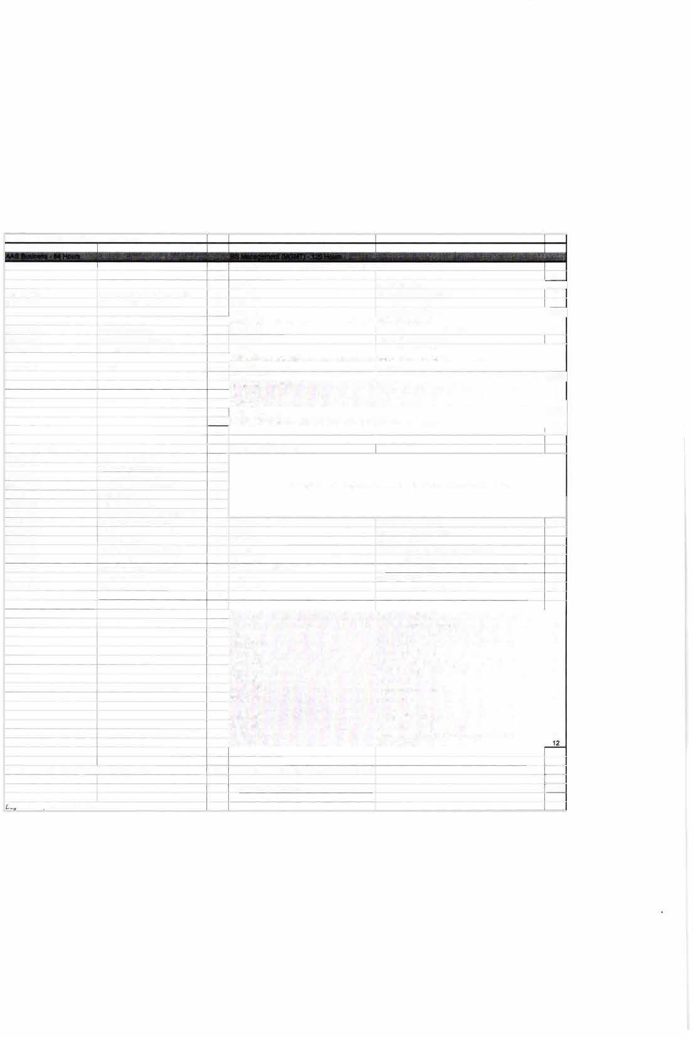

**18** I

**Proaram Reauirements Prooram Reauirements**

BUSI 2206 Business Dynamics 3

BUSI 2207 Business Oraanization 3

CSCI 1275 Microsoft Powerpoint 3

**MGMT** 2201 Principles of Management 3 **Any courses not articulated will** be **used to satisfy general elective credit**

MGMT 2207 Supervision 3

MRKT 2201 Principles of Markelina 3

OFTC 1206 Computerized Acct w/Ouickbooks 1

ACCO 1101 Prin Financial Accounting **4** ACCT 220 Accountina I-Financial T

ACCO 1102 Prin Managerial Accounting **4** ACCT 230 Accountina 11-Manaaerial T

BUSI 1101 Intro to Business 3 MGMT 170 Intro to Business T

BUSI 2105 Legat & Social Env Business 3 FIN 270 Legal & Social Environment of Business T

BUSI 2107 Business Communications 3 ENGL 291 Intermediate Technical Writing T CSCl 1102 Intro to Computers w/Busi App 3 CS 200B -or- ISAT 229 Computer Concepts -or- Computing Busi Admin T MATH 1108 College Algebra 3 MATH 108 Colleoe Alaebra T

MATH 2115 Calculus for Business **4** MATH 140 Short Course in Calculus T

**46**

BUS101 Open for Business 2

BUS 202 Business Career Transitions 2

FIN 330 Production-Operations Mgmt 3

**MGMT208** Business Data AnalySis 3

**MGMT304** Intro to Management 3

MGMT318 Production-Operations Mgmt 3

**MGMT:W5** Computer Information Sy.;tems 3

**MGMT 481** Administrative Policy 3

**MKTG 304** Mari<eting Management 3

COB Elecliw 300/400-level 3

MGMT :W1 Organizational Behavior 3

**MGMT 380** Managing Information Systems 3

**MGMT483** Advanced Production-Operations Management 3

Specialization 300/400-level

**49**

Total semester hrs completed with AAS dearee: **64** Total semester hrs completed with BS degree: 67

Total hrs to BS degree: 131

*�'96 Plan uodated on 2/1112020 bv* SG

------

,,

-:]

►-

R.END LAKE

C�C)L.L, GE

**TRANSFER GUIDE**

SIU

**AAS Business transferring into BS Management**

# CARBONDALE

## Rend Lake College Courses AAS Business - 64 hours

|  |  |  |  |
| --- | --- | --- | --- |
| ENGL 1101-3 | Rhetoric & Composition I | BUSI 2206-3 | Business Dynamics |
| ECON 1101-3 | Intro to Economics | BUSI 2207-3 | Business Organization |
| ECON 2101-3 | Principles of Economics I | CSCI 1102-3 | Into to Computers w/Busi App |
| ECON 2102-3 | Principles of Economics II | CSCI 1275-3 | Microsoft Powerpoint |
| COMM 1101-3 | Principles Effective Speaking | MATH 1108-3 | College Algebra |
| PHIL 2104-3 | Ethics | MATH 2115-4 | Calculus for Business |
| ACCO 1101-4 | Prin Financial Accounting | MGMT 2201-3 | Principles of Management |
| ACCO 1102-4 | Prin Managerial Accounting | MGMT 2207-3 | Supervision |
| BUSI 1101-3 | Intro to Business | MRKT 2201-3 | Principles of Marketing |
| BUSI 2105-3 | Legal & Social Env Business | OFTC 1206-1 | Computerized Acct w/Quickbooks |
| BUSI 2107-3 | Business Communications |  | |

**Southern Illinois University Carbondale Courses Capstone Option BS Management (MGMT) - 67 hours**

|  |  |
| --- | --- |
| MATH 139-3 Finite Mathematics | MGMT 318-3 Production-Operations Mgmt |
| PSYC 102/SOC 108-3 Intro to Psyc/lntro to Soc | MGMT 345-3 Computer Information Systems |
| Physical Science Elective-3 | MGMT 481-3 Administrative Policy |
| Life Science Elective-3 | MKTG 304-3 Marketing Management |
| Fine Arts Elective-3 | COB Elective-3 300/400-level |
| Multicultural Elective-3 | MGMT 341-3 Organizational Behavior |
| BUS 101-2 Open for Business | MGMT 380-3 Managing Information Systems |
| BUS 202-2 Business Career Transitions | MGMT 483-3 Adv Production-Operations Mgmt |
| FIN 330-3 Intro to Finance | Specialization-12 300/400-level |
| MGMT 208-3 Business Data Analysis |  |
| MGMT 304-3 Intro to Management |  |

**Total Hours to Bachelor Degree: 131 Hours**

*College of Business does not oversee facilitation of general education courses. UCC online course availability can be found at https://online.siu.edu/courses/index.php. In some cases, in person proctoring may be required.

# Questions? Contact Us!

## Salary Range: Possible Careers:

$38,000-$51,000

Branch Manager Budget Analyst Credit Manager Loan Officer

Customer Service Manager

## Rend Lake College

Jena Jensik, Director of Academic Advising

P: 618-437-5321, ext. 1293/E: [jensikj@rlc.edu](mailto:jensikj@rlc.edu)

## Southern Illinois University Carbondale

Jasmine Winters, Chief Academic Advisor

P: 618-453-7496/E: [jwinters@business.siu.edu](mailto:jwinters@business.siu.edu)



Disclaimer: You are encouraged to use this transfer guide when planning your progress towards degree completion. Following a transfer guide does not guarantee admission into the listed program. Information is attempted to be kept current; however, any curriculum changes reflected in the Undergraduate Catalog override the information on this guide. Contact your Academic Advisor for assistance in interpreting this guide.



# CARBONDALE

SIU

## Baccalaureate Degree Requirements

Each candidate for a bachelor's degree must complete the requirements listed:

***Hour Requirements.*** Each student must complete at least 120 semester hours of credit. Each student must have at least 42 hours in courses that number 300 or above from a four-year institution.

***Residence Requirements.*** Each student must complete the residence requirement by taking the last year, which is defined as 30 uninterrupted semester hours, or a total of 90 semester hours at SIU Carbondale.

***Grade Point Average Requirements.*** Each student must have a *C* average for all work taken at SIU Carbondale. Some academic programs may require a higher graduating major GPA.

## Dual Admission Program

The Dual Admission Program (DAP) allows baccalaureate-oriented students at eligible community colleges to benefit from pre-advisement for a chosen major at SIU Carbondale. The DAP addresses specific departmental requirements that a student may not automatically fulfill by completing their associate degree at their community college. Students apply to the DAP by completing the Application for Undergraduate Admission and indicating interest in the DAP. Students must have at least two semesters remaining at their community college to participate, must select a participating SIU major, and must attend an eligible community college. Students who apply for the OAP are provided a transfer plan that will guide them to the most direct route to their bachelor's degree, along with personalized contact with an SIU representative. Dual Admission Program students receive access to enroll in an online Dual Admission Program course, which connects students early to the University, its resources, and other transfer students.

## Compact Agreement

SIU has recognized the Illinois regionally accredited community college transferable baccalaureate oriented Associate of Arts or Associate of Science degrees under the Compact Agreement since 1970. SIU will continue to recognize the baccalaureate oriented associate degree (A.A. or A.S. degree) under the Illinois Articulation Initiative as satisfying SIU University Core Curriculum (UCC). The Associate of Applied Science (A.A.S.), Associate in Engineering Science (A.E.S.), the Associate in General Studies (A.G.S.), and the Associate in Fine Arts (A.F.A.) are not covered under the Compact Agreement and do not carry the same benefits as the A.A. and A.S. degrees.

## Degree Works

*Degree Works* is an easy-to-use, comprehensive, online degree audit tool specifically designed for students. The audit reflects program requirements from the Undergraduate Catalog measured against registration and transfer work to guide the degree audit function as it applies to the individual student. Once admitted to SIU Carbondale, you can run a Degree Works degree audit against your academic record by searching "Degree Works" in SalukiNet.