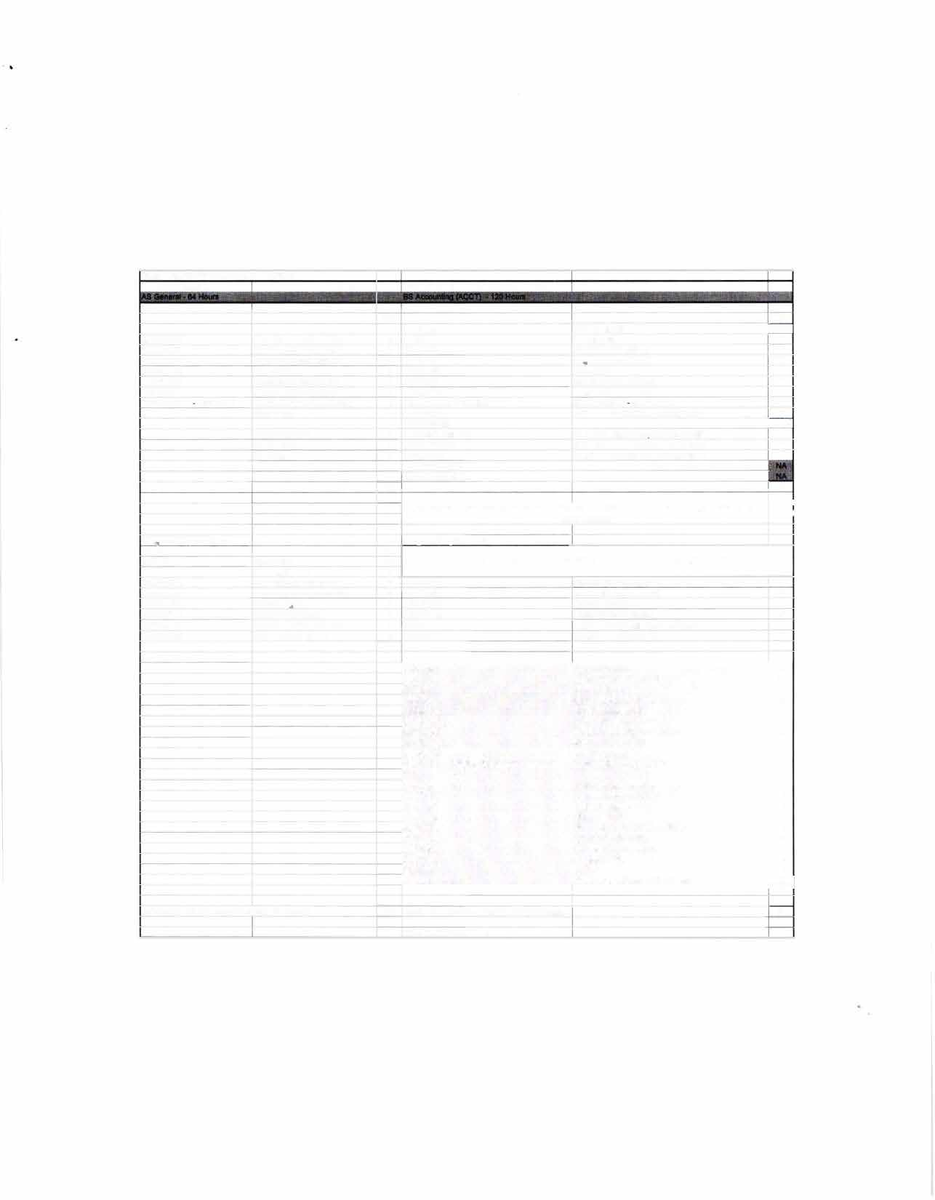

|  |  |  |  |  |  |
| --- | --- | --- | --- | --- | --- |
| PROGRAM ARTICULATION DE  *Rend Lake College*  COMM1101 ENGL1101 ENGL1102 MATH 2106 ECON2101 ECON2102  PSYC2101 -or SOCI1101  Program Requirements Electives  ORIE1101 | GREE PLAN  ***2019-2020***  Prin of Effective Soeaking Rhetoric & Composition l Rhetoric & Composition II Finite Math  Principles of Economics I Principles of Economics JI Intro to Psyc -or- Intro to Soc Humanities  PhYSical Science Life Science Fine Arts  Orientation | **Hrs**  3  3  3  3  3  3  3  3  3  **4**  3  **34**  **4.5** | *Southern lllinios University Carbondale*  UNIV101 CMST101 ENGL101 ENGL102 MATH139 ECON241 ECON **240**  PSYC102 -or- SOC 108 HUMANITIES HUMANITIES PHYSICAL SCIENCE LIFE SCIENCE  FINE ARTS HUMAN HEALTH MULTICULTURAL  An Associate of Science from a regionally a  req  Proaram Reauirements  Any courses not articulated w | Saluki Success  Intro Oral Communication Enalish Comoosition I English Composition ll Finite Mathematics  Intro to Macroeconomics Intro to Microeconomics Intro to Psvc -or Intro to Soc  See ***SJUC Transfer Equivalency Guide***  See ***SIUC Transfer Eauiva/encv Guide*** See ***SIUC Transfer Equivalency Guide See SfUC Transfer Equivafency Guide***  ccredited Illinois community college satisfies UCC uirements  ill be used to satisfy general elective credit | -**Hrs**  T  T T T T  -T  T  T  T T T  **0**  - |
|  | Science Elective | 3 |  |  |  |
| ACCO1101 | Prin Financial Accounting | **4** | ACCT220 | Accountina I-Financial | T |
| ACCO1102 | Prin Managerial Accounting | **4** | ACCT230 | Accountina 11-Manaaerial | T |
| MATH 1108 | College Algebra | 3 | MATH 108 | College Algebra | T |
| MATH 2103 | Business Statistics | 3 | MGMT208 | Business Data Analvsis | T |
| BUSI2105 | Legal & Social Env Business | 3 | FIN 270 | Legal & Social Environment of Business | T |
| MATH 2115 | Calculus for Business | **4** | MATH 140 | Short Course in Calculus | T |
|  |  | **30** |  |  |  |
|  |  |  |  |  |  |
|  |  |  | **BUS101** | Open for Business | **2** |
|  |  |  | **BUS202** | Business Career Transitions | **2** |
|  |  |  | **FIN 330** | Intro to Finance | 3 |
|  |  |  | **MGMT202** | Business Communications | **3** |
|  |  |  | **MGMT304** | Intro to Management | **3** |
|  |  |  | **MGMT318** | Production-Operations Mgmt | **3** |
|  |  |  | **MGMT345** | Computer Information Systems | **3** |
|  |  |  | **MGMT481** | Administrative Policy | **3** |
|  |  |  | **MKTG304** | Marketing Management | **3** |
|  |  |  | **COB Elective 300/400 level** | ACCT, FIN, **MGMT,** MKTG | 3 |
|  |  |  |  |  |  |
|  |  |  | ACCT321 | Intermediate Accounting I | 3 |
|  |  |  | ACCT322 | Intermediate Accounting II | 3 |
|  |  |  | ACCT331 | cost Accounting | 3 |
|  |  |  | ACCT341 | Intro to Taxation | 3 |
|  |  |  | ACCT360 | Accounting Systems Operations | **3** |
|  |  |  | ACCT421 | Advanced Accounting | 3 |
|  |  |  | ACCT431 | Advanced Cost Accounting | **3** |
|  |  |  | ACCT **441** | Advanced Tax | 3 |
|  |  |  | ACCT460 | Auditing | 3 |
| Total semester hrs comoleted | with AS deoree: | **64** | ACCT Elective  Total semester hrs completed with BS degree: Total hrs to es dearee: | ACCT **411, 465, 468, 471** -or- **495** | �**58**  **58**  122 |

# CARBONDALE

SIU

**TRANSFER GUIDE**

**AS General transferring into BS Accounting**

**Rend Lake College Courses AS General - 64 hours**

|  |  |
| --- | --- |
| ENGL 1101-3 Rhetoric & Composition I  ENGL 1102-3 Rhetoric & Composition II | Elective-3 Science Elective  PSYC 2101/SOC 1101-3 Intro to Psyc/lntro to Soc |
| COMM 1101-3 Principles of Effective Speaking | ACCO 1101-4 Prin Financial Accounting |
| MATH 2106-3 Finite Math | ACCO 1102-4 Prin Managerial Accounting |
| ECON 2101-3 Principles of Economics I | MATH 2103-3 Business Statistics |
| ECON 2102-3 Principles of Economics II | BUSI 2105-3 Legal & Social Env Business |
| Elective-3 Humanities | MATH 2115-4 Calculus for Business |
| Elective-3 Physical Science | MATH 1108-3 College Algebra |
| Elective-4 Life Science | ORIE 1101-1.5 Orientation |
| Elective-3 Fine Arts | Electives-4.5 |

**Southern Illinois University Carbondale Courses BSAccounting (ACCT) - 58 hours**

|  |  |  |  |
| --- | --- | --- | --- |
| BUS 101-2 | Open for Business | ACCT 321-3 | Intermediate Accounting I |
| BUS 202-2 | Business Career Transitions | ACCT 322-3 | Intermediate Accounting II |
| FIN 330-3 | Intro to Finance | ACCT 331-3 | Cost Accounting |
| MGMT 202-3 | Business Communications | ACCT 341-3 | Intro to Taxation |
| MGMT 304-3 | Intro to Management | ACCT 360-3 | Accounting Systems Operations |
| MGMT 318-3 | Production-Operations Mgmt | ACCT 421-3 | Advanced Accounting |
| MGMT 345-3 | Computer Information Systems | ACCT 431-3 | Advanced Cost Accounting |
| MGMT 481-3 | Administrative Policy | ACCT 441-3 | Advanced Tax |
| MKTG 304-3 | Marketing Management | ACCT 460-3 | Auditing |
| COB Elective-3 | 300/400-level | ACCT Elective-3 | ACCT 411, 465, 468, 471/495 |

**Total Hours to Bachelor Degree: 122 Hours**

# Questions? Contact Us!

**Rend Lake College**

Jena Jensik

Director of Academic Advising

**Salary Range:**

$46,000-$78,000

P: 618-437-5321, ext. 1293

E: [jensikj@rlc.edu](mailto:jensikj@rlc.edu)

**Possible Careers:** Certified Public Accountant

Internal Auditor Budget Analyst Consultant

**Southern Illinois University Carbondale**

Jasmine Winters

Chief Academic Advisor P: 618-453-7496

E: [jwinters@business.siu.edu](mailto:jwinters@business.siu.edu)



Disclaimer: You are encouraged to use this transfer guide when planning your progress towards degree completion. Following a transfer guide does not guarantee admission into the listed program. Information is attempted to be kept current; however, any curriculum changes reflected in the Undergraduate Catalog override the information on this guide. Contact your Academic Advisor for assistance in interpreting this guide.



# CARBONDALE

**SIU**

**Baccalaureate Degree Requirements**

Each candidate for a bachelor's degree must complete the requirements listed:

***Hour Requirements.*** Each student must complete at least 120 semester hours of credit. Each student must have at least 42 hours in courses that number 300 or above from a four-year institution.

***Residence Requirements.*** Each student must complete the residence requirement by taking the last year, which is defined as 30 uninterrupted semester hours, or a total of 90 semester hours at SIU Carbondale.

***Grade Point Average Requirements.*** Each student must have a *C* average for all work taken at SIU Carbondale. Some academic programs may require a higher graduating major GPA.

**Dual Admission Program**

The Dual Admission Program (DAP) allows baccalaureate-oriented students at eligible community colleges to benefit from pre-advisement for a chosen major at SIU Carbondale. The DAP addresses specific departmental requirements that a student may not automatically fulfill by completing their associate degree at their community college. Students apply to the DAP by completing the Application for Undergraduate Admission and indicating interest in the DAP. Students must have at least two semesters remaining at their community college to participate, must select a participating SIU major, and must attend an eligible community college. Students who apply for the DAP are provided a transfer plan that will guide them to the most direct route to their bachelor's degree, along with personalized contact with an SIU representative. Dual Admission Program students receive access to enroll in an online Dual Admission Program course, which connects students early to the University, its resources, and other transfer students.

**Compact Agreement**

SIU has recognized the Illinois regionally accredited community college transferable baccalaureate oriented Associate of Arts or Associate of Science degrees under the Compact Agreement since 1970. SIU will continue to recognize the baccalaureate oriented associate degree (A.A. or A.S. degree) under the Illinois Articulation Initiative as satisfying SIU University Core Curriculum (UCC). The Associate of Applied Science (A.A.S.), Associate in Engineering Science (A.E.S.), the Associate in General Studies (A.G.S.), and the Associate in Fine Arts (A.F.A.) are not covered under the Compact Agreement and do not carry the same benefits as the A.A. and A.S. degrees.

**Degree Works**

*Degree Works* is an easy-to-use, comprehensive, online degree audit tool specifically designed for students. The audit reflects program requirements from the Undergraduate Catalog measured against registration and transfer work to guide the degree audit function as it applies to the individual student. Once admitted to SIU Carbondale, you can run a Degree Works degree audit against your academic record by searching "Degree Works" in SalukiNet.