PROGRAM ARTICULATION DEGREE PLAN

***Rend Lake College 2019-2020 Southern lllinlos University Carbondale***

-**Hrs**·

-

|  |  |  |  |  |  |
| --- | --- | --- | --- | --- | --- |
|  | | Hrs |  | | |
|  |  |  | UNIV 101 | Saluki Success |  |
| COMM 1101 | Prin of Effective Speaking | 3 | CMST 101 | Intro Oral Corrrnunication | T |
| ENGL 1101 | Rhetoric & Composition I | 3 | ENGL 101 | EnQ ish Composition I | T |
| ENGL 1102 | Rhetoric & Comoosition II | 3 | ENGL 102 | Enalish Comoosition II | T |
| MATH 2106 | Finite Math | 3 | MATH 139 | Finite Mathematics | T |
| ECON 2101 | Princicles of Economics I | 3 | ECON 241 | Intro to Macroeconomics | T |
| ECON 2102 | Principles of Economics II | 3 | ECON 240 | Intro to Microeconomics | T |
| PSYC 2101 -or- SOCl 1101 | Intro to Psyc -or- Intro to Soc | 3 | PSYC 102 -or- SOC 108 | Intro to Psvc --or- Intro to Soc | T |
|  | Humanities | 3 | HUMANITIES | *See SIUC Transfer Eauivalencv Guide* | T |
|  |  |  | HUMANITIES |  |  |
|  | Physical Science | 3 | PHYSICAL SCIENCE | See *SIUC Transfer Equivalency Guide* | T |
|  | Life Science | **4** | LIFE SCIENCE | *See S/UC Transfer Eauivalencv Guide* | T |
|  | Fine Arts | 3 | FINE ARTS | See *SIUC Transfer Equivalency Guide* | T |
|  |  |  | HUMAN HEALTH |  |  |
|  |  |  | MULTICULTURAL |  |  |
|  |  | **34** |  |  | 0 |

**An Associate of Science from a regionally accredited Illinois community college satisfies UCC**

reauirements

Program Requirements Proaram Reauirements I

Electives 4.5

ORIE 1101 Orientation 1.5 Any courses not articulated will be used to satisfy general elective credit Science Elective 3

ACCO 1101 Prin Financial Accounting **4** ACCT 220 Accountina I-Financial T

ACCO 1102 Prin Managerial Accounting **4** ACCT 230 Accountina 11-Manaaerial T

MATH 1108 College Algebra 3 MATH 108 ColleQe AIQebra T MATH 2103 Business Statistics **3** MGMT 208 Business Data Analvsis T BUSI 2105 Legal & Social Env Business 3 FIN 270 Leaal & Social Environment of Business T

MATH 2115 Calculus for Business **4** MATH 140 Short Course in Calculus T

**30**

**BUS 101** Open for Business **2**

**BUS 202** Business Career Transitions **2**

**FIN330** Intro to Finance **3**

**MGMT 202** Business Conmunications 3

**MGMT 304** Intro to Management 3

**MGMT** 318 Production-Operations Mgmt 3

**MGMT 345** Computer Information Systems 3

**MGMT 481** Administrative Policy 3

**MKTG 304** Marketing Management 3

**COB Elective 300/400 level** ACCT, FIN, MGMT, MKTG 3

**FIN331** Investments 3

**FIN341** Financial Markets 3

FIN 361 Management of Business Finance 3

ACCT 321 -or- 331 lntermed Accounting I -or- Cost Accounting 3

Specialization 400-level FIN courses 15

**Elective**

I

,.......L

**56**

Total semester hrs completed with AS degree: **64** Total semester hrs comoleted with BS dearee: **56**

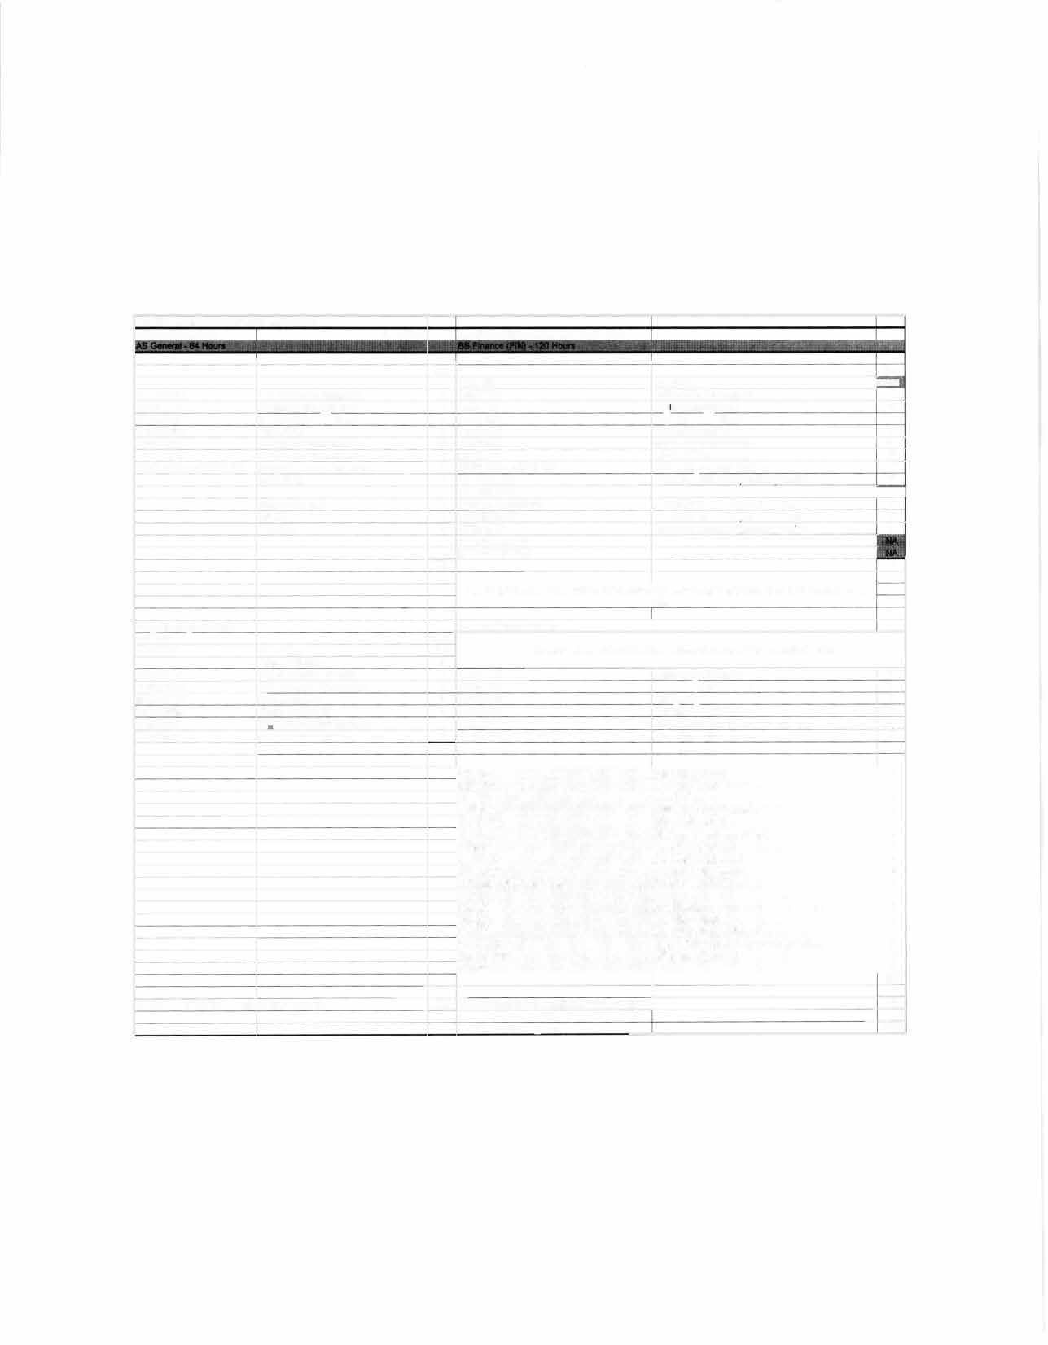

Total hrs to BS dearee: 120

�ti

�

fZ-E-· -�ND LAKE

CARBONDALE

SIU

(_, I . l... rL·'. "'.�J E·••�

**TRANSFER GUIDE**

**AS General transferring into BS Finance**

## Rend Lake College Courses AS General - 64 hours

|  |  |  |  |
| --- | --- | --- | --- |
| ENGL 1101-3 | Rhetoric & Composition I | Elective-3 | Science Elective |
| ENGL 1102-3 | Rhetoric & Composition II | PSYC 2101/SOC 1101-3 | Intro to Psyc/lntro to Soc |
| COMM 1101-3 | Principles of Effective Speaking | ACCO 1101-4 | Prin Financial Accounting |
| MATH 2106-3 | Finite Math | ACCO 1102-4 | Prin Managerial Accounting |
| ECON 2101-3 | Principles of Economics I | MATH 2103-3 | Business Statistics |
| ECON 2102-3 | Principles of Economics II | BUSI 2105-3 | Legal & Social Env Business |
| Elective-3 | Humanities | MATH 1108-3 | College Algebra |
| Elective-3 | Physical Science | MATH 2115-4 | Calculus for Business |
| Elective-4 | Life Science | ORIE 1101-1.5 | Orientation |
| Elective-3 | Fine Arts | Electives-4.S | |

**Southern Illinois University Carbondale Courses BS Finance (FIN) - 56 hours**

|  |  |  |  |
| --- | --- | --- | --- |
| BUS 101-2 | Open for Business | MKTG 304-3 | Marketing Management |
| BUS 202-2 | Business Career Transitions | COB Elective-3 | 300/400-level |
| FIN 330-3 | Intro to Finance | FIN 331-3 | Investments |
| MGMT 202-3 | Business Communications | FIN 341-3 | Financial Markets |
| MGMT 304-3 Intro to Management | | FIN 361-3 | Mgmt of Business Finance |
| MGMT 318-3 | Production-Operations Mgmt | ACCT 321/331-3 | lntermed Accounting I/Cost Acct |
| MGMT 345-3 | Computer Information Systems | Specialization-ls | 400-level FIN courses |
| MGMT 481-3 | Administrative Policy | Elective-1 | |

**Total Hours to Bachelor Degree: 120 Hours**

**Questions? Contact Us!**

**Salary Range:**

$46,000-$55,000

## Rend Lake College

Jena Jensik

Director of Academic Advising

**Possible Careers:** Financial Planner

Investor Relations Associate Financial Analyst

Budget Analyst

P: 618-437-5321, ext. 1293

E: [jensikj@rlc.edu](mailto:jensikj@rlc.edu)

Credit Analyst **Southern Illinois University Carbondale**



Jasmine Winters

Chief Academic Advisor P: 618-453-7496

E: [jwinters@business.siu.edu](mailto:jwinters@business.siu.edu)

Disclaimer: You are encourage� to use t�is transfer guide when planning your progress towards degree completion. Following a transfer guide

does not guarantee admrssron rnto �he lrsted program. Information is attempted to be kept current; however, any curriculum changes reflected

rn the Undergraduate Catalog override the information on this guide. Contact your Academic Advisor for assistance in interpreting this guide.



# CARBONDALE

SIU

## Baccalaureate Degree Requirements

Each candidate for a bachelor's degree must complete the requirements listed:

***Hour Requirements.*** Each student must complete at least 120 semester hours of credit. Each student must have at least 42 hours in courses that number 300 or above from a four-year institution.

***Residence Requirements.*** Each student must complete the residence requirement by taking the last year, which is defined as 30 uninterrupted semester hours, or a total of 90 semester hours at SIU Carbondale.

***Grade Point Average Requirements.*** Each student must have a *C* average for all work taken at SIU Carbondale. Some academic programs may require a higher graduating major GPA.

## Dual Admission Program

The Dual Admission Program (OAP) allows baccalaureate-oriented students at eligible community colleges to benefit from pre-advisement for a chosen major at SIU Carbondale. The OAP addresses specific departmental requirements that a student may not automatically fulfill by completing their associate degree at their community college. Students apply to the OAP by completing the Application for Undergraduate Admission and indicating interest in the OAP. Students must have at least two semesters remaining at their community college to participate, must select a participating SIU major, and must attend an eligible community college. Students who apply for the OAP are provided a transfer plan that will guide them to the most direct route to their bachelor's degree, along with personalized contact with an SIU representative. Dual Admission Program students receive access to enroll in an online Dual Admission Program course, which connects students early to the University, its resources, and other transfer students.

## Compact Agreement

SIU has recognized the Illinois regionally accredited community college transferable baccalaureate oriented Associate of Arts or Associate of Science degrees under the Compact Agreement since 1970. SIU will continue to recognize the baccalaureate oriented associate degree (A.A. or A.S. degree) under the Illinois Articulation Initiative as satisfying SIU University Core Curriculum (UCC). The Associate of Applied Science (A.A.S.), Associate in Engineering Science (A.E.S.), the Associate in General Studies (A.G.S.), and the Associate in Fine Arts (A.F.A.) are not covered under the Compact Agreement and do not carry the same benefits as the A.A. and A.S. degrees.

## Degree Works

*Degree Works* is an easy-to-use, comprehensive, online degree audit tool specifically designed for students. The audit reflects program requirements from the Undergraduate Catalog measured against registration and transfer work to guide the degree audit function as it applies to the individual student. Once admitted to SIU Carbondale, you can run a Degree Works degree audit against your academic record by searching "Degree Works" in SalukiNet.