**PROGRAM ARTICULATION DEGREE PLAN**

***Rend L•ke College 2019-2020* Southern *11/inlcn University C•rbondale***

# -

**Hrs Hrs**

**UNIV101 Saluki Success**

**COMM1101 Prin of Effedive Speaking 3 CMST 101 Intro Oral Communication T**

**ENGL1101 Rhetoric & Composition I 3 ENGL101 English Composition I T**

**ENGL1102 Rhetoric & Comoosition II 3 ENGL102 Enolish Comoosition II T**

**MATH2106 Finite Math 3 MATH139 Finite Mathematics T ECON2101 Principles of Economics I 3 ECON241 Intro to Macroeconomics T**

-

**ECON2102 Princi°'es of Economics II 3 ECON240 Intro to Microeconomics T PSYC2101 -or- SOCI1101 Intro to Psyc -or- Intro to Soc 3 PSYC102 -or- SOC108 Intro to Psvc -or- Intro to Soc T Humanities 3 HUMANITIES See *SIUC Transfer Eouivslencv Guide* T**

**HUMANITIES**

**Physical Science 3 PHYSICAL SCIENCE See S/UC *Transfer Equiva/ency Guide* T Life Science 4 LIFE SCIENCE See *SIUC Transfer Equivalency Guide* T**

**Fine Arts 3 FINE ARTS *See SIUC Transfer Eouivalencv Guide* T**

**HUMAN HEALTH**

**MULTICULTURAL** -

**34 0**

**An Associate of Science from a regionally accredited Illinois community college satisfies UCC requirements**

**Proaram Reauirements Proaram Reauirements** I

**Electives 4.5**

**ORIE1101 Orientation Any courses not articulated will be used to satisfy general elective credit**

|  |  |  |  |  |  |
| --- | --- | --- | --- | --- | --- |
|  | **Science Elective** | **3** |  | | |
| **ACCO1101** | **Prin Financial Accounting** | **4** | **ACCT220** | **Accounting I-Financial** | **T** |
| **ACCO1102** | **Prin Manaaerial Accountina** | **4** | **ACCT230** | **Accountina 11-Manaaerial** | **T** |
| **BUSI2105** | **Leaal & Social Env Business** | **3** | **FIN270** | **Leaal & Social Environment of Business** | **T** |
| **MATH1108** | **College Algebra** | **3** | **MATH108** | **College Algebra** | **T** |
| **MATH2103** | **Business Statistics** | **3** | **MGMT208** | **Business Data Analvsis** | **T** |
| **MATH2115** | **Calculus for Business** | **4** | **MATH140** | **Short Course in Calculus** | **T** |
|  |  | **30** |  |  |  |
|  |  |  |  |  |  |
|  |  |  | **BUS101** | **Open for Business** | **2** |
|  |  |  | **BUS202** | **Business CarNr Transitions** | **2** |
|  |  |  | **FIN330** | **Intro to Finance** | **3** |
|  |  |  | **MGMT202** | **Busineu Communications** | **3** |
|  |  |  | **MGMT3Q.4** | **Intro to Management** | **3** |
|  |  |  | **MGMT318** | **Production-Operations Mgmt** | **3** |
|  |  |  | **MGMT345** | **Computer Information Systems** | **3** |
|  |  |  | **MGMT481** | **Administrative Policy** | **3** |
|  |  |  | **MKTG30-4** | **Marketing Management** | **3** |
|  |  |  | **COB Elective300/400 level** | **ACCT, FIN, MGMT, MKTG** | **3** |
|  |  |  |  |  |  |
|  |  |  | **MGMT341** | **Organizational Behavior** | **3** |
|  |  |  | **MGMT380** | **Managing Information Systems** | **3** |
|  |  |  | **MGMT483** | **Advanced Production-Operations Management** | **3** |
|  |  |  | **Specialization** | **300/400-level** | **12** |

**Electives**

""T6"

**Total semester hrs completed with AS dearee: 64 Total semester hrs completed with BS degree: 56**

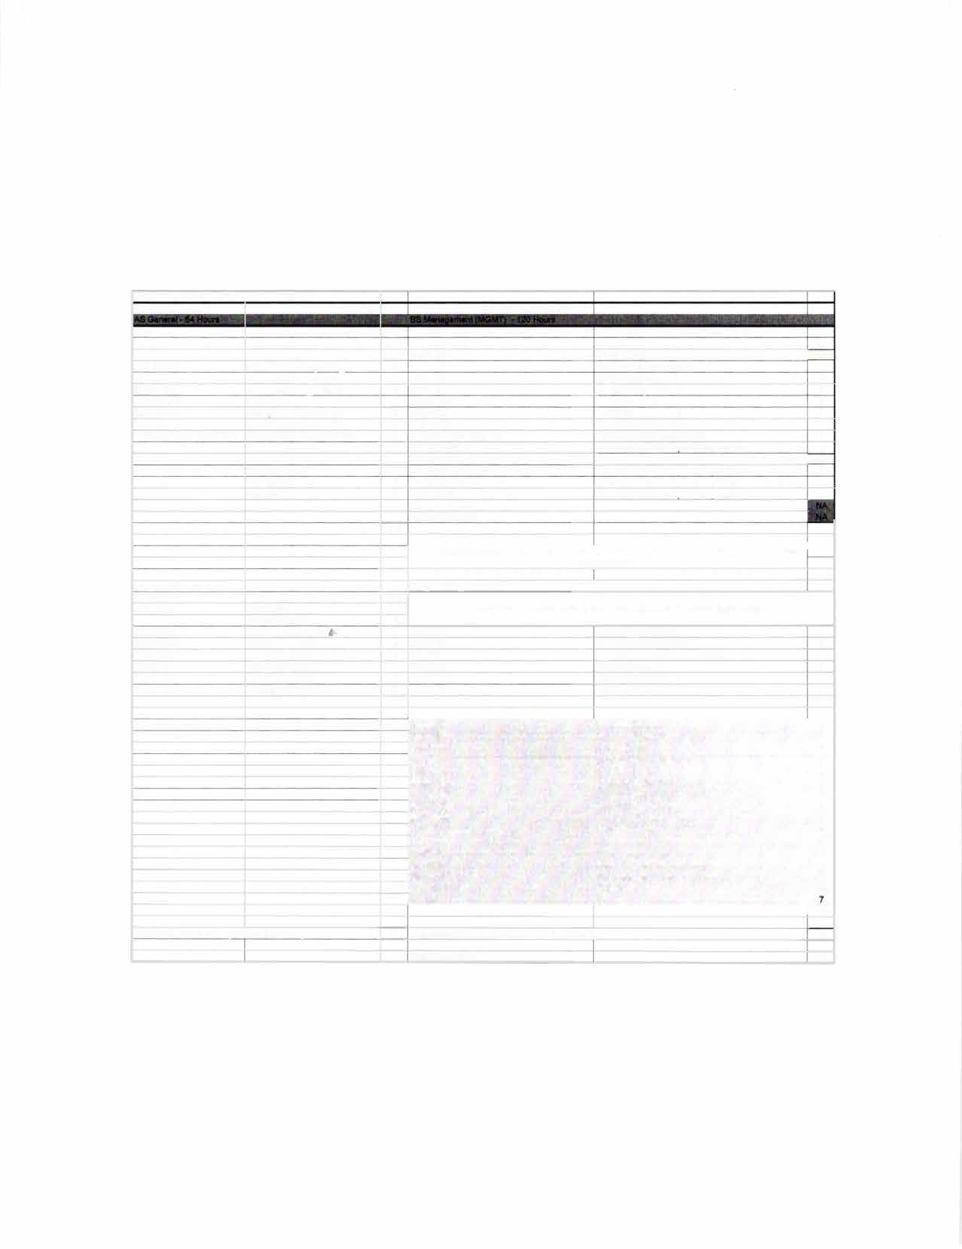

**Total hrs to BS dearee: 120**

* :')-i"].

·

►--11

**SIU**

r I

REND LAKE

## CARBONDALE

(-) I., c··J···�

**TRANSFER GUIDE**

**AS General transferring into BS Management**

### Rend Lake College Courses AS General - 64 hours

|  |  |  |  |
| --- | --- | --- | --- |
| ENGL 1101-3 | Rhetoric & Composition I | Elective-3 | Fine Arts |
| ENGL 1102-3 | Rhetoric & Composition II | Elective-3 | Science Elective |
| COMM 1101-3 | Principles of Effective Speaking | ACCO 1101-4 | Prin Financial Accounting |
| MATH 2106-3 | Finite Math | ACCO 1102-4 | Prin Managerial Accounting |
| ECON 2101-3 | Principles of Economics I | MATH 2103-3 | Business Statistics |
| ECON 2102-3 | Principles of Economics II | BUSI 2105-3 | Legal & Social Env Business |
| Elective-3 | Humanities | MATH 1108-3 | College Algebra |
| PSYC 2101/SOCI 1101-3 | Intro to Psyc/lntro to Soc | MATH 2115-4 | Calculus for Business |
| Elective-3 | Physical Science | ORIE 1101-1.5 | Orientation |
| Elective-4 | Life Science | Electives-4.5 | |

**Southern Illinois University Carbondale Courses**

**BS Management (MGMT) - 56 hours**

|  |  |  |  |
| --- | --- | --- | --- |
| BUS 101-2  BUS 202-2  FIN 330-3 | Open for Business  Business Career Transitions  Intro to Finance | MKTG 304-3  COB Elective-3  MGMT 341-3 | Marketing Management  300/400-level Organizational Behavior |
| MGMT 202-3 | Business Communications | MGMT 380-3 | Managing Information Systems |
| MGMT 304-3 | Intro to Management | MGMT 483-3 | Adv Production-Operations Mgmt |
| MGMT 318-3 | Production-Operations Mgmt | Specialization-12 | 300/400-level |
| MGMT 345-3  MGMT 481-3 | Computer Information Systems Administrative Policy | Electives-7 | |

**Total Hours to Bachelor Degree: 120 Hours**

**Questions? Contact Us!**

**Salary Range: Possible Careers:**

**$38,000-$51,000**

Branch Manager Budget Analyst Credit Manager Loan Officer

Customer Service Manager

### Rend Lake College

Jena Jensik

Director of Academic Advising P: 618-437-5321, ext. 1293

E: [jensikj@rlc.edu](mailto:jensikj@rlc.edu)

### Southern Illinois University Carbondale

Jasmine Winters

Chief Academic Advisor P: 618-453-7496

E: [jwinters@business.siu.edu](mailto:jwinters@business.siu.edu)

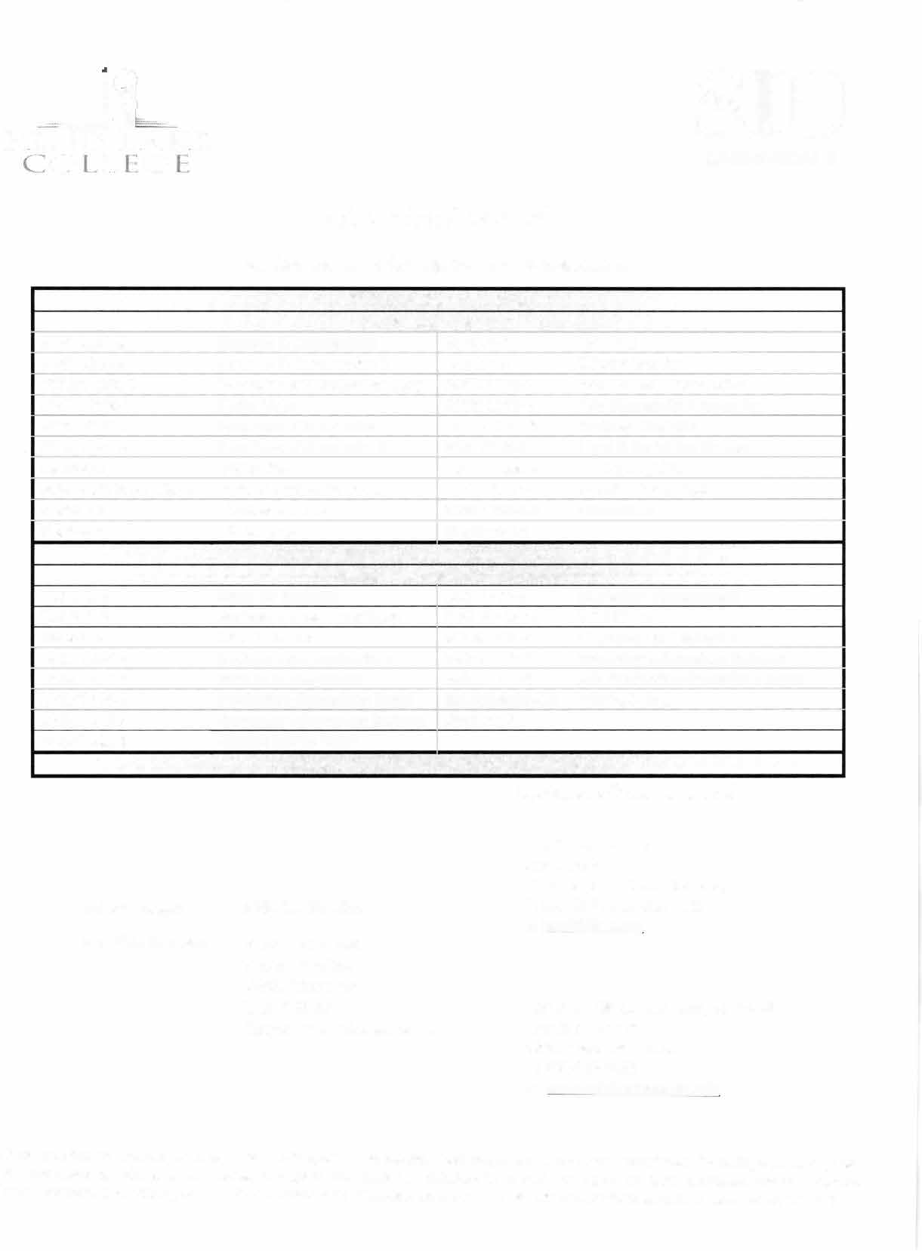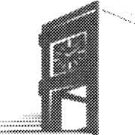

Disclaimer: You are encouraged to use this transfer guide when planning your progress towards degree completion. Following a transfer guide

?oes not guarantee admission into the listed program. Information is attempted to be kept current; however, any curriculum changes reflected in the Undergraduate Catalog override the information on this guide. Contact your Academic Advisor for assistance in interpreting this guide.



**CARBONDALE**

**SIU**

### Baccalaureate Degree Requirements

Each candidate for a bachelor's degree must complete the requirements listed:

***Hour Requirements.*** Each student must complete at least 120 semester hours of credit. Each student must have at least 42 hours in courses that number 300 or above from a four-year institution.

***Residence Requirements.*** Each student must complete the residence requirement by taking the last year, which is defined as 30 uninterrupted semester hours, or a total of 90 semester hours at SIU Carbondale.

***Grade Point Average Requirements.*** Each student must have a *C* average for all work taken at SIU Carbondale. Some academic programs may require a higher graduating major GPA.

### Dual Admission Program

The Dual Admission Program (DAP) allows baccalaureate-oriented students at eligible community colleges to benefit from pre-advisement for a chosen major at SIU Carbondale. The DAP addresses specific departmental requirements that a student may not automatically fulfill by completing their associate degree at their community college. Students apply to the DAP by completing the Application for Undergraduate Admission and indicating interest in the DAP. Students must have at least two semesters remaining at their community college to participate, must select a participating SIU major, and must attend an eligible community college. Students who apply for the DAP are provided a transfer plan that will guide them to the most direct route to their bachelor's degree, along with personalized contact with an SIU representative. Dual Admission Program students receive access to enroll in an online Dual Admission Program course, which connects students early to the University, its resources, and other transfer students.

### Compact Agreement

SIU has recognized the Illinois regionally accredited community college transferable baccalaureate oriented Associate of Arts or Associate of Science degrees under the Compact Agreement since 1970. SIU will continue to recognize the baccalaureate oriented associate degree (A.A. or A.S. degree) under the Illinois Articulation Initiative as satisfying SIU University Core Curriculum (UCC). The Associate of Applied Science (A.A.S.), Associate in Engineering Science (A.E.S.), the Associate in General Studies (A.G.S.), and the Associate in Fine Arts (A.F.A.) are not covered under the Compact Agreement and do not carry the same benefits as the A.A. and A.S. degrees.

### Degree Works

*Degree Works* is an easy-to-use, comprehensive, online degree audit tool specifically designed for students. The audit reflects program requirements from the Undergraduate Catalog measured against registration and transfer work to guide the degree audit function as it applies to the individual student. Once admitted to SIU Carbondale, you can run a Degree Works degree audit against your academic record by searching "Degree Works" in SalukiNet.