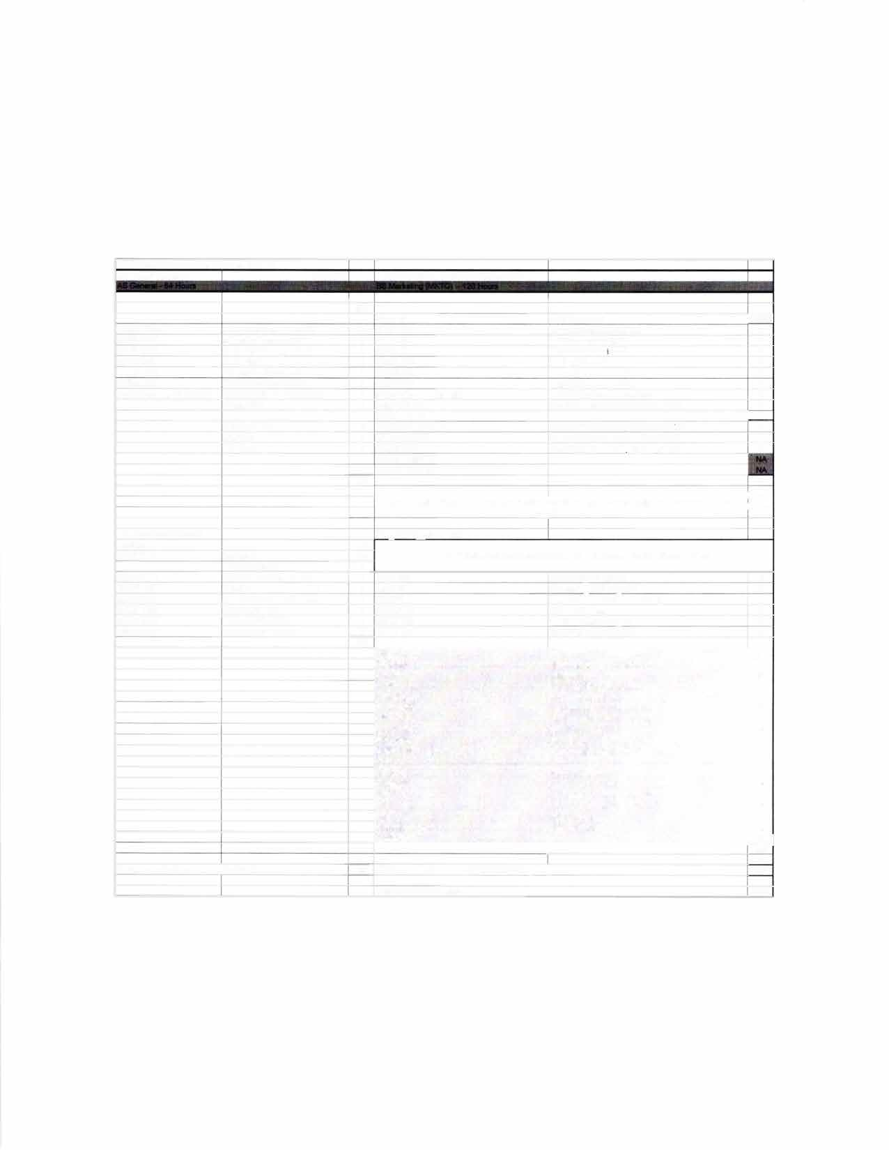

**Total hrs to BS degree:**

I

I

|  |  |  |  |  |  |
| --- | --- | --- | --- | --- | --- |
| **PROGRAM ARTICULATION DEGREE PLAN**  ***Rend Lake College 2019-2020***  **COMM1101 Prin of Effective Soeakina**  **ENGL1101 Rhetoric & Composition I**  **ENGL1102 Rhetoric & Composition 11**  **MATH2106 Finite Math**  **ECON2101 Princioles of Economics t**  **ECON2102 Principles of Economics II PSYC2101 -or- SOCI1101 Intro to Psyc -or- Intro to Soc**  **Humanities**  **Physical Science Life Science Fine Arts**  **Proaram Reauirements Electives**  **ORIE 1101 Orientation** | | **Hrs 3**  **3**  **3**  **3**  **3**  **3**  **3**  **3**  **3**  **4**  **3**  **34**  **4.5**  **1.5** | **Southam *llllnlos University Carbondale***  **UNIV101 CMST101 ENGL101 ENGL102 MATH139 ECON241 ECON240**  **PSYC102 -or- SOC108 HUMANITIES HUMANITIES PHYSICAL SCIENCE LIFE SCIENCE**  **FINE ARTS HUMAN HEALTH MULTICULTURAL**  **An Associate of Science from a regionally a**  **Proaram ReQuirements**  **Any courses not articulated w** | **Saluki Success** -**Hrs**  **Intro Oral Communication T**  **English Composition I T**  **English Compostion II T**  **Finite Mathematics T**  **Intro to Macroeconomics T**  **Intro to Microeconomics** -**T**  **Intro to Psyc -or- Intro to Soc T**  **See** *SIUC Transfer Equivalency Guide* **T**  **See** *SIUC Transfer Equivalency Guide* **T** *See SIUC Transfer Equivalency Guide* **T** *See SIUC Transfer Eauivalencv Guide* **T**  **0**  �  **ccredited Illinois community college satisfies UCC** �  **requirements**  **ill be used to satisfy general elective credit** | |
|  | **Science Elective** | **3** |  |  |  |
| **ACCO1101** | **Prin Financial Accountina** | **4** | **ACCT220** | **Accounting I-Financial** | **T** |
| **ACCO1102** | **Prin Managerial Accounting** | **4** | **ACCT230** | **Accounting II-Managerial** | **T** |
| **BUSI2105** | **Leaal & Social Env Business** | **3** | **FIN270** | **Legat & Social Environment of Business** | **T** |
| **MATH1108** | **Colleoe Algebra** | **3** | **MATH108** | **Colleoe Alaebra** | **T** |
| **MATH2103** | **Business Statistics** | **3** | **MGMT208** | **Business Data Anatvsis** | **T** |
| **MATH2115** | **Calculus for Business** | **4** | **MATH140** | **Short Course in Calculus** | **T** |
|  |  | **30** |  |  |  |
|  |  |  | **BUS101** | **Open for Business** | **2** |
|  |  |  | **BUS202** | **Business Career Transitions** | **2** |
|  |  |  | **FIN330** | **Intro to Finance** | **3** |
|  |  |  | **MGMT202** | **Business Communications** | **3** |
|  |  |  | **MGMT304** | **Intro to Management** | **3** |
|  |  |  | **MGMT318** | **Production-Operations Mgmt** | **3** |
|  |  |  | **MGMT345** | **Computer Information Systems** | **3** |
|  |  |  | **MGMT481** | **Administrative Policy** | **3** |
|  |  |  | **MKTG304** | **Mar1<eting Management** | **3** |
|  |  |  | **COB Eleciive3004/ 00l<tvel** | **ACCT, FIN, MGMT, MKTG** | **3** |
|  |  |  | **MKTG305** | **Consumer Behavior** | **3** |
|  |  |  | **MKTG329** | **Marketing Channels** | **3** |
|  |  |  | **MKTG 363** | **Strategic Promotion Management** | **3** |
|  |  |  | **MKTG390** | **Mar1<eting Research & Analysis** | **3** |
|  |  |  | **MKTG493** | **Mar1<eting Strategy** | **3** |
|  |  |  | **Marketing Electives** | **300/400-level** | **9** |
|  |  |  | **Electives** I �  **56** | | |
| **Total semester hrs comcleted with AS dearee:** | | **64** | **Total semester hrs completed with BS degree:** | | **56** |
|  | |  |  | |  |
|  | |  |  | | **120** |

# CARBONDALE

**SIU**

**TRANSFER GUIDE**

**AS General transferring into BS Marketing**

**Rend Lake College Courses AS General - 64 hours**

|  |  |  |  |
| --- | --- | --- | --- |
| ENGL 1101-3 | Rhetoric & Composition I | Elective-3 | Fine Arts |
| ENGL 1102-3 | Rhetoric & Composition II | Elective-3 | Science Elective |
| COMM 1101-3 | Principles of Effective Speaking | ACCO 1101-4 | Prin Financial Accounting |
| MATH 2106-3 | Finite Math | ACCO 1102-4 | Prin Managerial Accounting |
| ECON 2101-3 | Principles of Economics I | MATH 2103-3 | Business Statistics |
| ECON 2102-3 | Principles of Economics II | BUSI 2105-3 | Legal & Social Env Business |
| PSYC 2101/SOCI 1101-3 | Intro to Psyc/lntro to Soc | MATH 1108-3 | College Algebra |
| Elective-3 | Humanities | MATH 2115-4 | Calculus for Business |
| Elective-3 | Physical Science | ORIE 1101-1.5 | Orientation |
| Elective-4 | Life Science | Electives-4.5 | |

**Southern Illinois University Carbondale Courses**

**BS Marketing (MKTG) - 56 hours**

|  |  |  |  |
| --- | --- | --- | --- |
| BUS 101-2 | Open for Business | COB Elective-3 | 300/400-level • |
| BUS 202-2 | Business Career Transitions | MKTG 305-3 | Consumer Behavior |
| FIN 330-3 | Intro to Finance | MKTG 329-3 | Marketing Channels |
| MGMT 202-3 | Business Communications | MKTG 363-3 | Strategic Promotion Management |
| MGMT 304-3 | Intro to Management | MKTG 390-3 | Marketing Research & Analysis |
| MGMT 318-3 | Production-Operations Mgmt | MKTG 493-3 | Marketing Strategy |
| MGMT 345-3 | Computer Information Systems | MKTG Electives-9 | 300/400-level |
| MGMT 481-3 | Administrative Policy | Electives-4 | |
| MKTG 304-3 | Marketing Management |  | |

**Total Hours to Bachelor Degree: 120 Hours**

# Questions? Contact Us!

**Salary Range: Possible Careers:**

$41,000-$51,000

Marketing Account Executive Marketing Analyst

Marketing Assistant Business Dev Representative

Marketing Sales Representative

**Rend Lake College**

Jena Jensik

Director of Academic Advising P: 618-437-5321, ext. 1293

E: [jensikj@rlc.edu](mailto:jensikj@rlc.edu)

**Southern Illinois University Carbondale**

Jasmine Winters

Chief Academic Advisor P: 618-453-7496

E: [jwinters@business.siu.edu](mailto:jwinters@business.siu.edu)



Disclaimer: You are encouraged to use this transfer guide when planning your progress towards degree completion. Following a transfer guide does not guarantee admission into the listed program. Information is attempted to be kept current; however, any curriculum changes reflected in the Undergraduate Catalog override the information on this guide. Contact your Academic Advisor for assistance in interpreting this guide.



,' \

# CARBONDALE

**Baccalaureate Degree Requirements**

SIU

Each candidate for a bachelor's degree must complete the requirements listed:

***Hour Requirements.*** Each student must complete at least 120 semester hours of credit. Each student must have at least 42 hours in courses that number 300 or above from a four-year institution.

***Residence Requirements.*** Each student must complete the residence requirement by taking the last year, which is defined as 30 uninterrupted semester hours, or a total of 90 semester hours at SIU Carbondale.

***Grade Point Average Requirements.*** Each student must have a C average for all work taken at SIU Carbondale. Some academic programs may require a higher graduating major GPA.

**Dual Admission Program**

The Dual Admission Program (DAP) allows baccalaureate-oriented students at eligible community colleges to benefit from pre-advisement for a chosen major at SIU Carbondale. The DAP addresses specific departmental requirements that a student may not automatically fulfill by completing their

' associate degree at their community college. Students apply to the DAP by completing the Application for Undergraduate Admission and indicating interest in the DAP. Students must have at least two semesters remaining at their community college to participate, must select a participating SIU major, and must attend an eligible community college. Students who apply for the DAP are provided a transfer plan that will guide them to the most direct route to their bachelor's degree, along with personalized contact with an SIU representative. Dual Admission Program students receive access to enroll in an online Dual Admission Program course, which connects students early to the University, its resources, and other transfer students.

**Compact Agreement**

SIU has recognized the Illinois regionally accredited community college transferable baccalaureate oriented Associate of Arts or Associate of Science degrees under the Compact Agreement since 1970. SIU will continue to recognize the baccalaureate oriented associate degree {A.A. or A.S. degree) under the Illinois Articulation Initiative as satisfying SIU University Core Curriculum (UCC). The Associate of Applied Science (A.A.S.), Associate in Engineering Science (A.E.S.), the Associate in General Studies (A.G.S.), and the Associate in Fine Arts (A.F.A.) are not covered under the Compact Agreement and do not carry the same benefits as the A.A. and A.S. degrees.

**Degree Works**

*Degree Works* is an easy-to-use, comprehensive, online degree audit tool specifically designed for students. The audit reflects program requirements from the Undergraduate Catalog measured against registration and transfer work to guide the degree audit function as it applies to the individual student. Once admitted to SIU Carbondale, you can run a Degree Works degree audit against your academic record by searching "Degree Works" in SalukiNet.