Print Management Guide

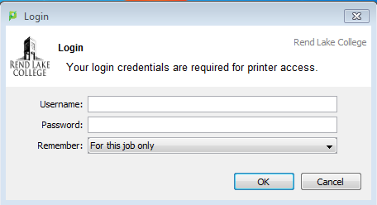

To access your RLC Print Management Web Portal, go to <http://pm.rlc.edu> you will be taken to the Print Management login page. Students will use Canvas username and password to access Print Management account.

**Use these pages to check print balance/history or add value to accounts:**

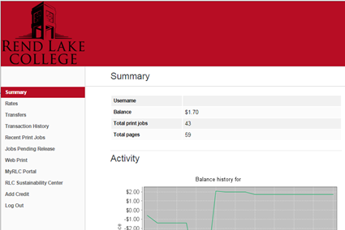

**Summary** – Users can view monetary balance, total number of print jobs, total printed pages, balance history, and view details of how printing at RLC impacts the environment.

**Transaction History** – provides a detailed list of all printing, when it was printed, how much it cost, balance after printing, and transaction type.

**Recent Print Jobs** – provides detailed information about most recent print jobs. This page also allows users to request a refund for a print job. Users must enter a *Reason for* Request for the request to be reviewed. Reason examples could include paper jam, printer failure/malfunction, etc. Refunds WILL NOT be given for improperly formatted pages, accidental printing or any other issues arising from user errors. Refund request will be reviewed on a case by case basis.

**Add Credit** link takes users to PayPal web payment portal. Users must have personal PayPal accounts to add credit (increments of $5.00) to Print Management account. *This link is for adding credit with debit/credit cards only*. Please see staff in LRC, Business Office, RLMP or MurphyWall campus to add cash value.

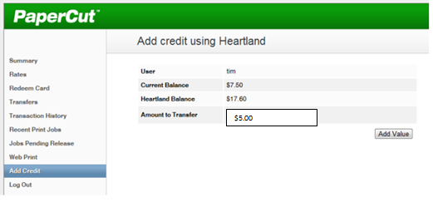

**Remember to click LOG OUT to protect your account!**